Name: ______________________
Grade

Astronomical Redshift

Pre-Lab Quiz:
Record your answers as well as your reasonings and explanations.

1.
2.
3.
4.
5.
Measuring Redshifted Wavelengths
Using the distances and spectra of quasars (old, bright galaxies) and Hubble’s Law (relating distance to galaxies and their recessional velocities), you will determine Hubble’s constant and the age of the Universe.

The Balmer series of hydrogen includes Hα (H-alpha) at 6565 Ångstroms in visible wavelengths. You studied Hα when you completed your Observations of the Sun lab. Many Solar telescopes look at the Sun at this wavelength using an Hα filter, including the Solar telescopes we have in the lab room. 6565 Ångstroms is the rest wavelength, λ_{rest}, of Hα.

Most galaxies have hydrogen features in their spectrum, such as the visible light spectrum of the quasar SDSS J0927 shown below (its name comes from its Right Ascension (RA)). Examine this spectrum; note how the broad labeled Hα feature is easily identifiable because it is a very strong (tall) emission line in this visible range, and is redward (to the right) of a unique grouping of emission lines: a strong broad line with two strong narrow lines just to the red (right) (Hβ and two [OIII] lines, also labeled with arrows).

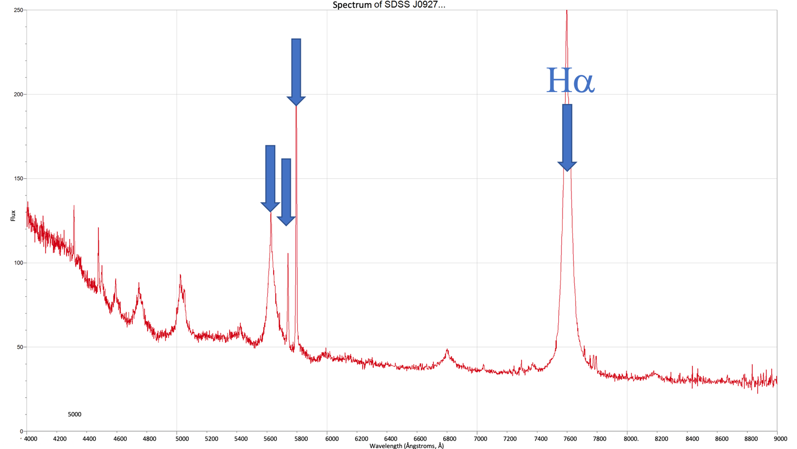

Note how even though the rest wavelength, λ_{rest}, of Hα is 6565Å, in the quasar spectrum the Hα appears at about 7600Å. This is because the emission line has been redshifted due to the quasars recessional velocity. The observed wavelength of Hα, λ_{obs}, for this quasar is 7600Å.

The change between the observed wavelength λ_{obs} and the rest wavelength λ_{rest} of a galaxy can be called $∆λ$. These values are related by the formula:
$$∆λ=λ_{obs}-λ_{rest}$$

When we know what $∆λ$ is equal to, the amount of redshift of the galaxy, z, can be calculated with the formula:

$$z=\frac{∆λ}{λ_{rest}}$$

Furthermore, when we know $z$ we can find the recessional velocity v of a quasar:

$$v=cz$$

where $c$is the speed of light which is 300,000 km/s (kilometers per second).

1. Complete this table by identifying Hα (λ_{rest} = 6565Å) in the quasar spectra on the following pages and using the equations on the previous page. The second column lists each quasar’s distance d. d is given for you in Mpc (megaparsecs, millions of parsecs); examining the angular size of a quasar can determine its distance as you did in your Image Analysis I lab. Record the quasars’ observed Hα wavelengths λ_{obs} and find their Δλ, redshift z, and recessional velocity v. The first 2 quasars have been done for you as examples, so you will only need to do the 5 on pages 7-9.

Quasar | distance d  (Mpc) | λ_{obs}  (Å) | Δλ = λ_{obs} – λ_{rest}  (Å) | $$z=\frac{∆λ}{λ_{rest}}$$ | $$v=cz$$  (km/s)
J0927  (page 6) | 586 Mpc | 7600Å | Δλ = 7600Å - 6565Å  = 1035 Å | $$z=\frac{1035 Å}{6565Å}$$  = 0.16 | v=300000×0.16  =48000 km/s
J1236  (page 6) | 681 Mpc | 7800Å | Δλ = 7800Å - 6565Å  = 1235 Å | $$z=\frac{1235 Å}{6565Å}$$  = 0.19 | v=300000×0.16  =57000 km/s
J1400  (page 7) | 367 Mpc
J1452  (page 7) | 602 Mpc
J1458  (page 8) | 940 Mpc
J1509  (page 8) | 990 Mpc
J2105  (page 9) | 213 Mpc
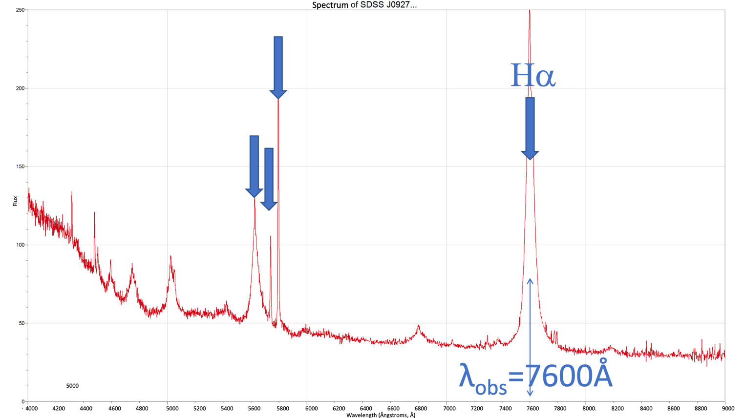

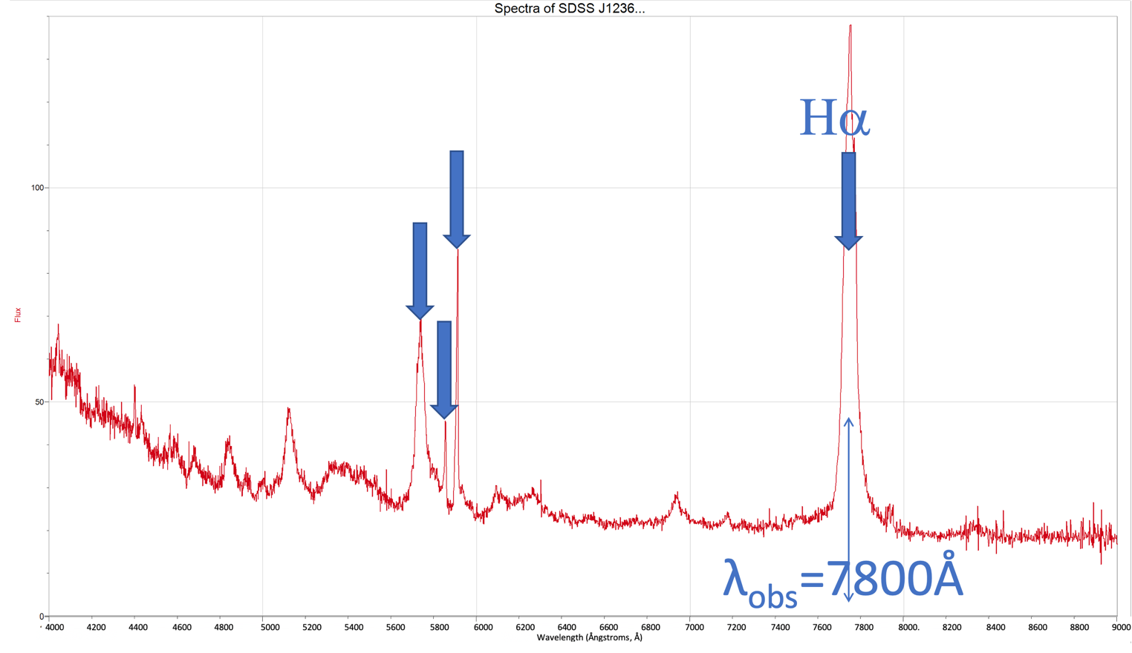
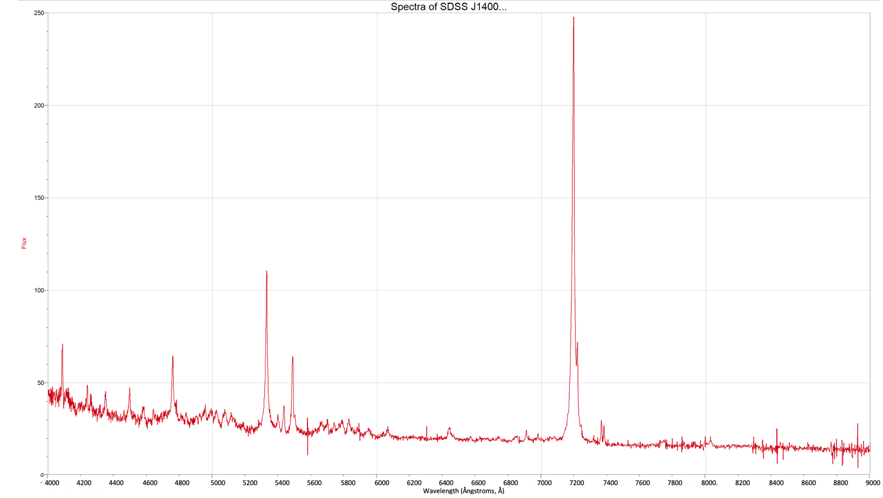

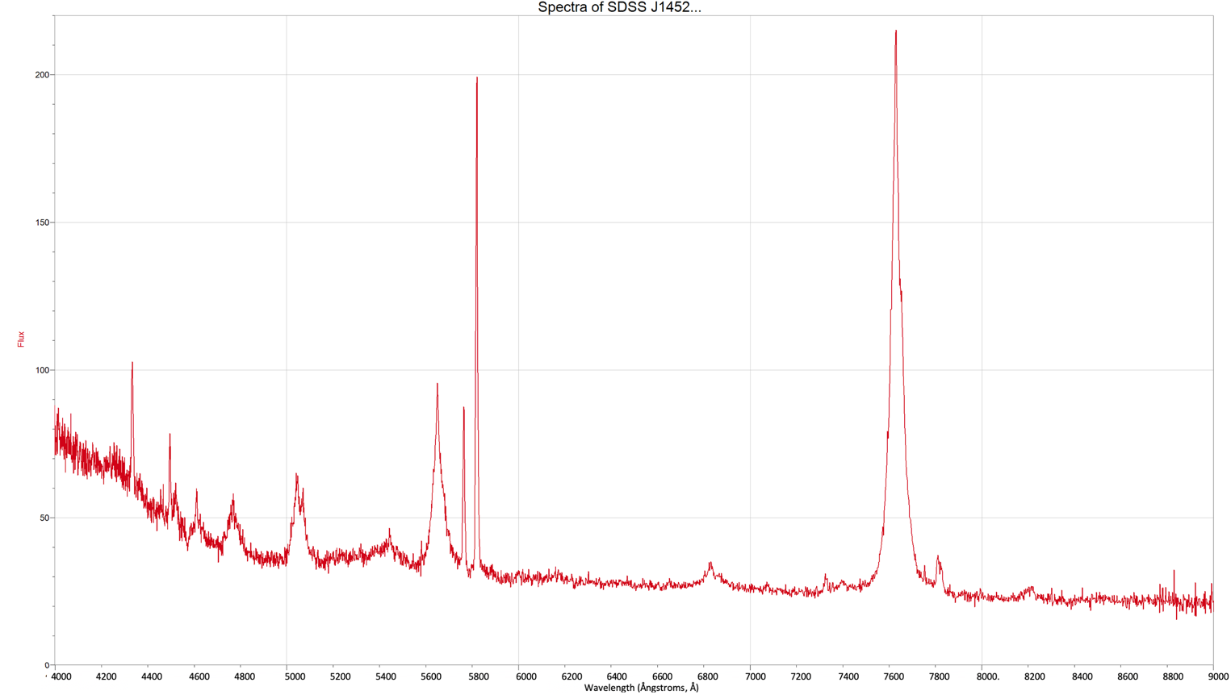
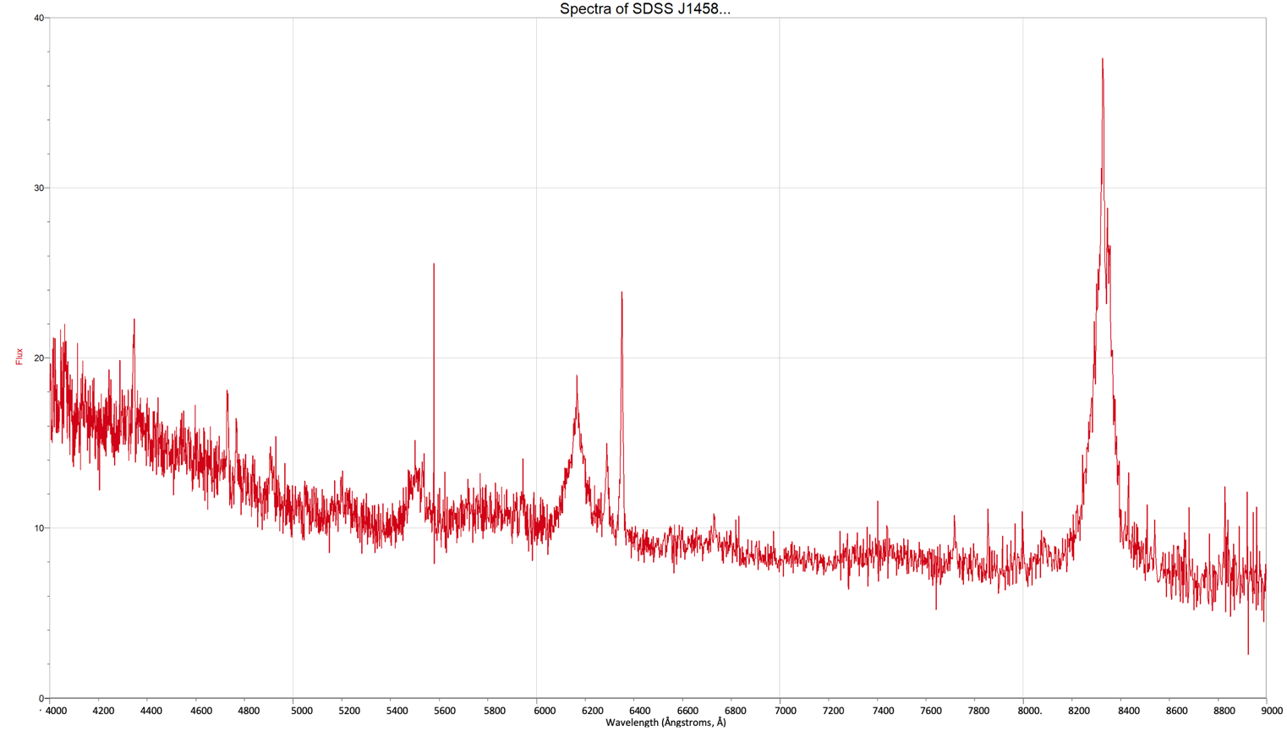

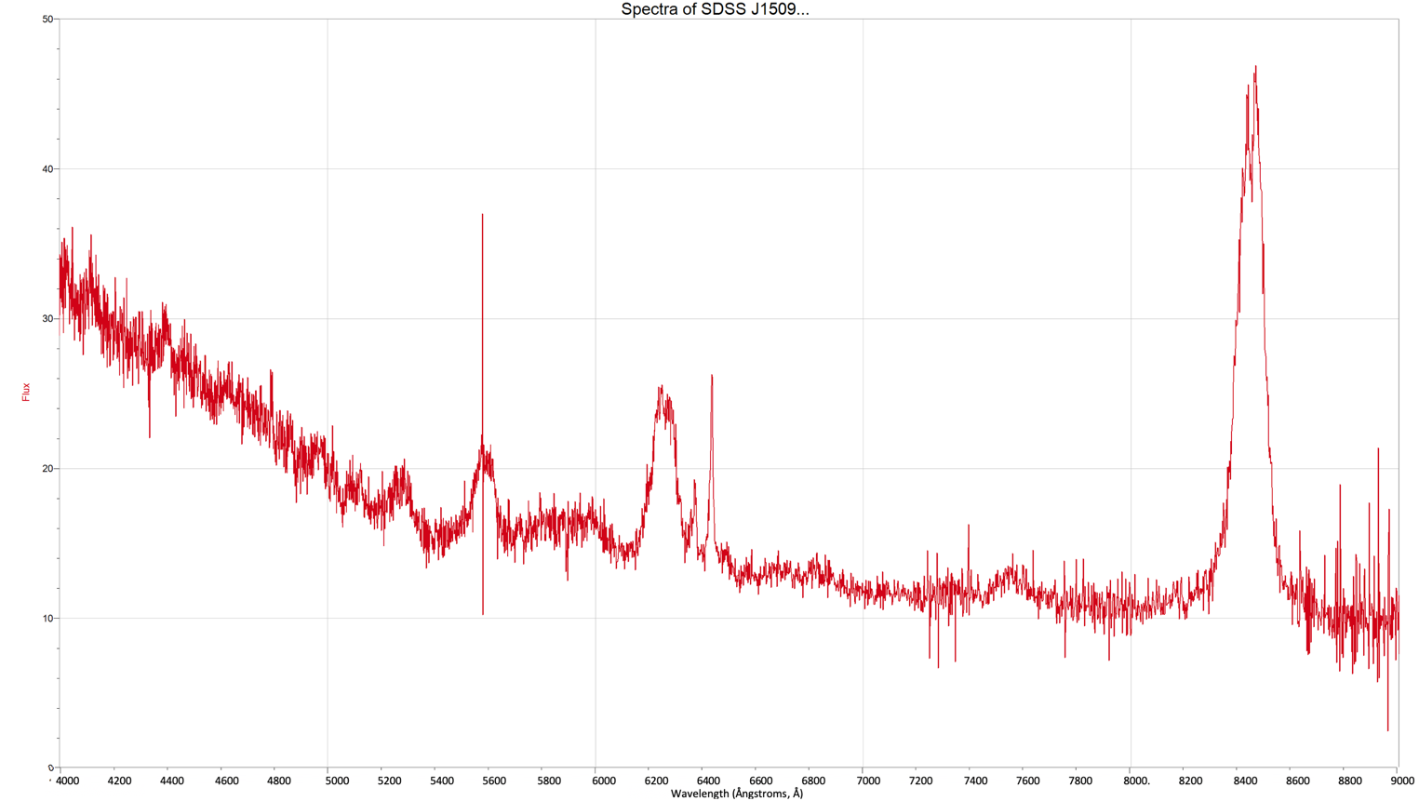
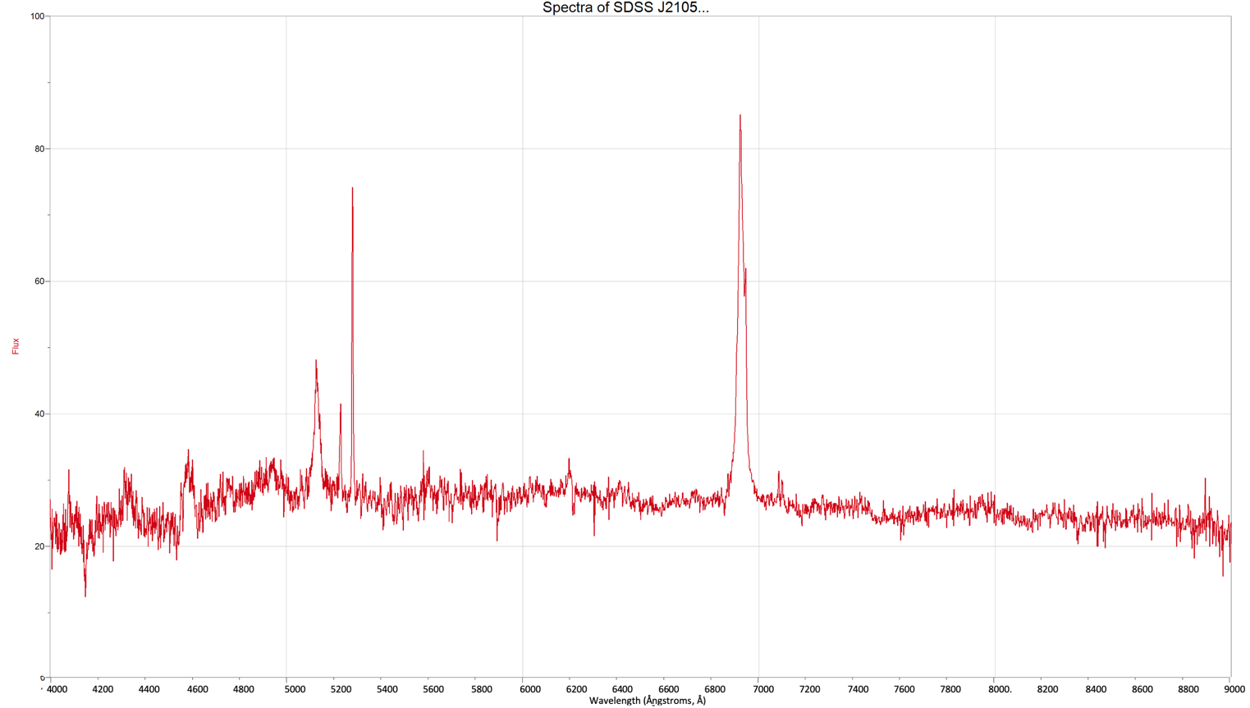

2. Now plot the quasar data from the table you completed on page 5. You have 7 quasars so you will need to have 7 points on your plot. The first two have been done for you as an example. Your x-axis will be distance d (Mpc) (the red, second column) and your y-axis will be recessional velocity v (km/s) (the blue, last column).

You may find it helpful to review plotting coordinate pairs at the following links:

https://www.khanacademy.org/math/basic-geo/basic-geo-coord-plane/coordinate-plane-4-quad/v/plot-ordered-pairs

https://www.khanacademy.org/math/basic-geo/basic-geo-coord-plane/coordinate-plane-4-quad/v/the-coordinate-plane

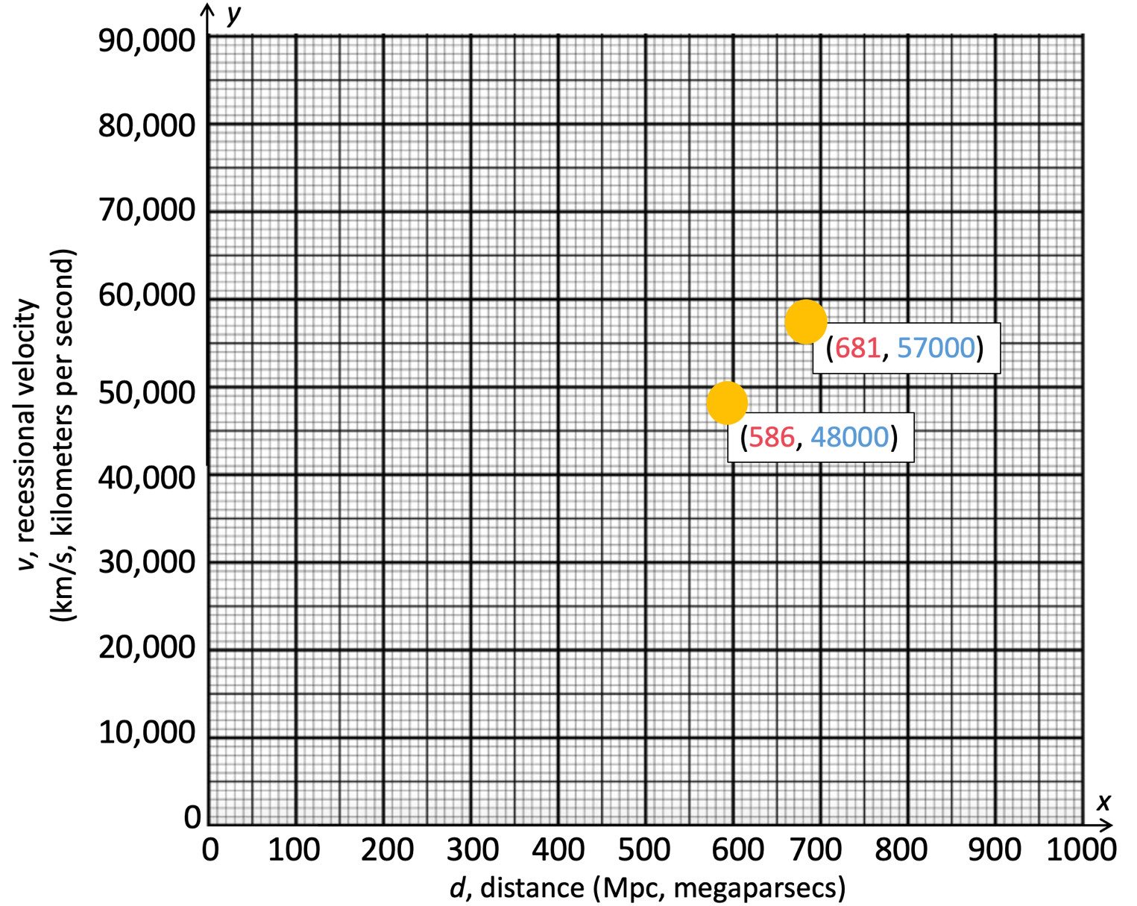

3. Draw a best-fit line on your plot above. A best fit line is a straight line that goes though or near as many points as possible. Find the slope of this best-fit line, showing your work below. This slope value is Hubble’s constant, H₀.

To help with this, an example of drawing a best-fit line and finding the slope is below; the data are not correct but the method will be the same for your data points. You may also find it helpful to review finding the slope of a line at the following link:

https://www.khanacademy.org/math/algebra/x2f8bb11595b61c86:linear-equations-graphs/x2f8bb11595b61c86:slope/v/slope-of-a-line

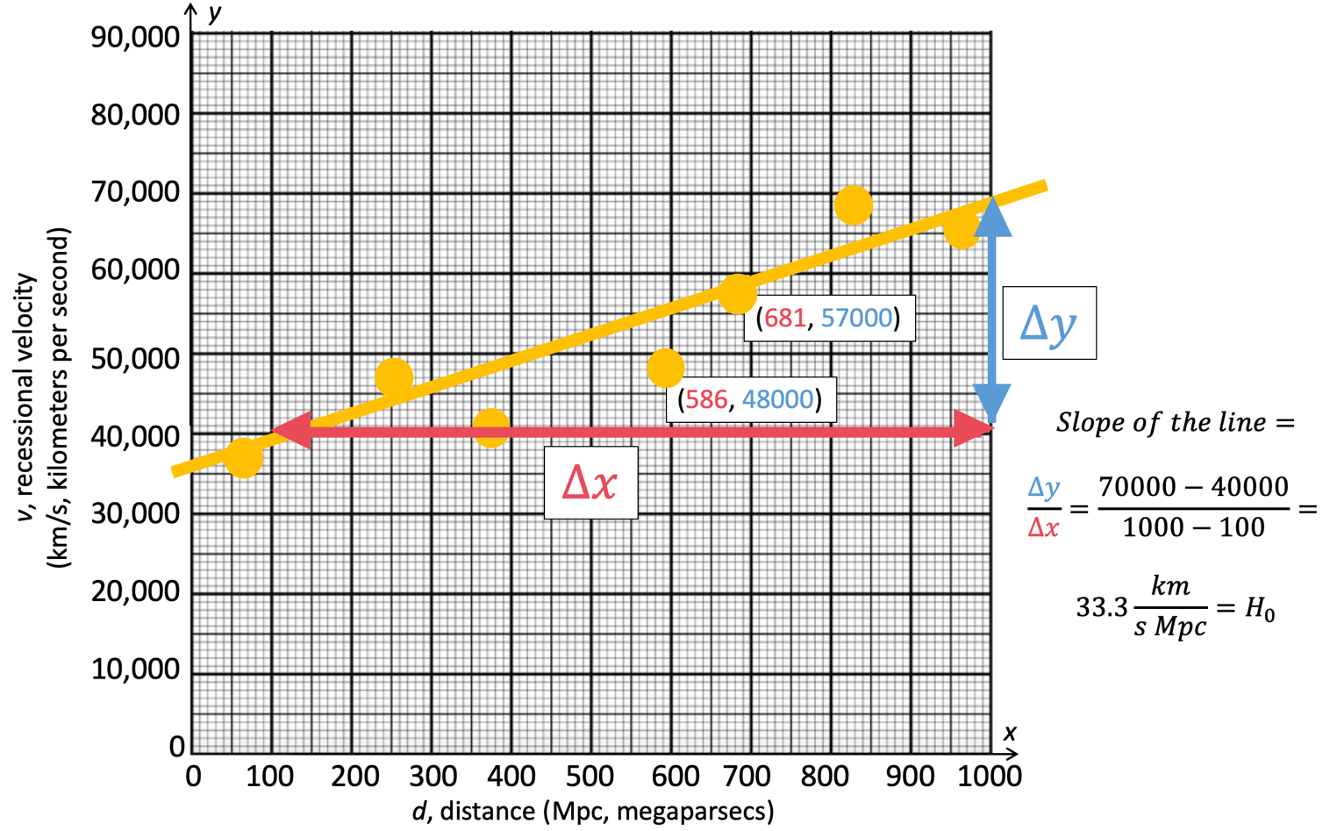
4. Take the number 1 and divide it by your value of the Hubble constant H₀ (find the reciprocal of H₀). Then multiply this new number by 978 (the number of km in a Mpc divided by the number of seconds in a billion years). This is the age of the Universe in billions of years. What value did you get? How does this compare with the known age of the Universe?

