Names:

Grade

Measuring the Sky

Pre-Lab Quiz:
Record you team’s answer as well as your reasonings and explanations.

1.
2.
3.
4.

Part 1: The Celestial Sphere

- On the figure below, label the Earth’s Equator, the Celestial Equator, the Ecliptic, the North Celestial Pole (NCP), the South Celestial Pole (SCP), the Earth’s Rotational Axis, and the position of the star Polaris. On this diagram of the celestial sphere, label the Sun’s position when the Summer Solstice, Winter Solstice, Vernal Equinox, and Autumnal Equinox occur.
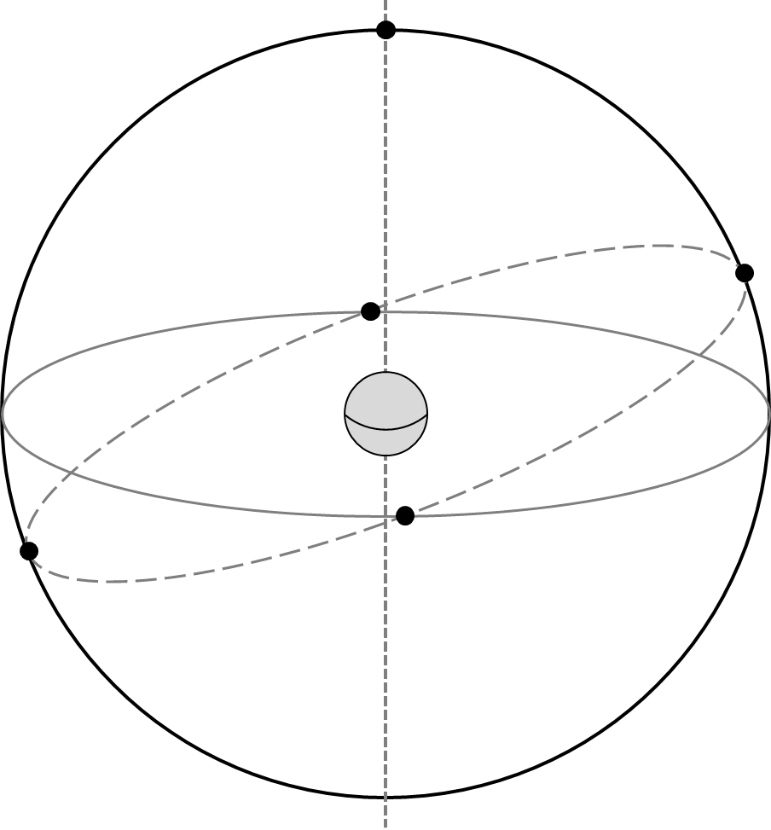
- What angle is the ecliptic inclined with respect to the celestial equator? Include units in your answer.

- What celestial objects lay on or near the ecliptic? Name at least five. Explain more about your answers: What is the significance of the ecliptic? Why do so many noteworthy celestial objects lie in this area of the sky?

The Celestial Sphere: Local Viewpoint

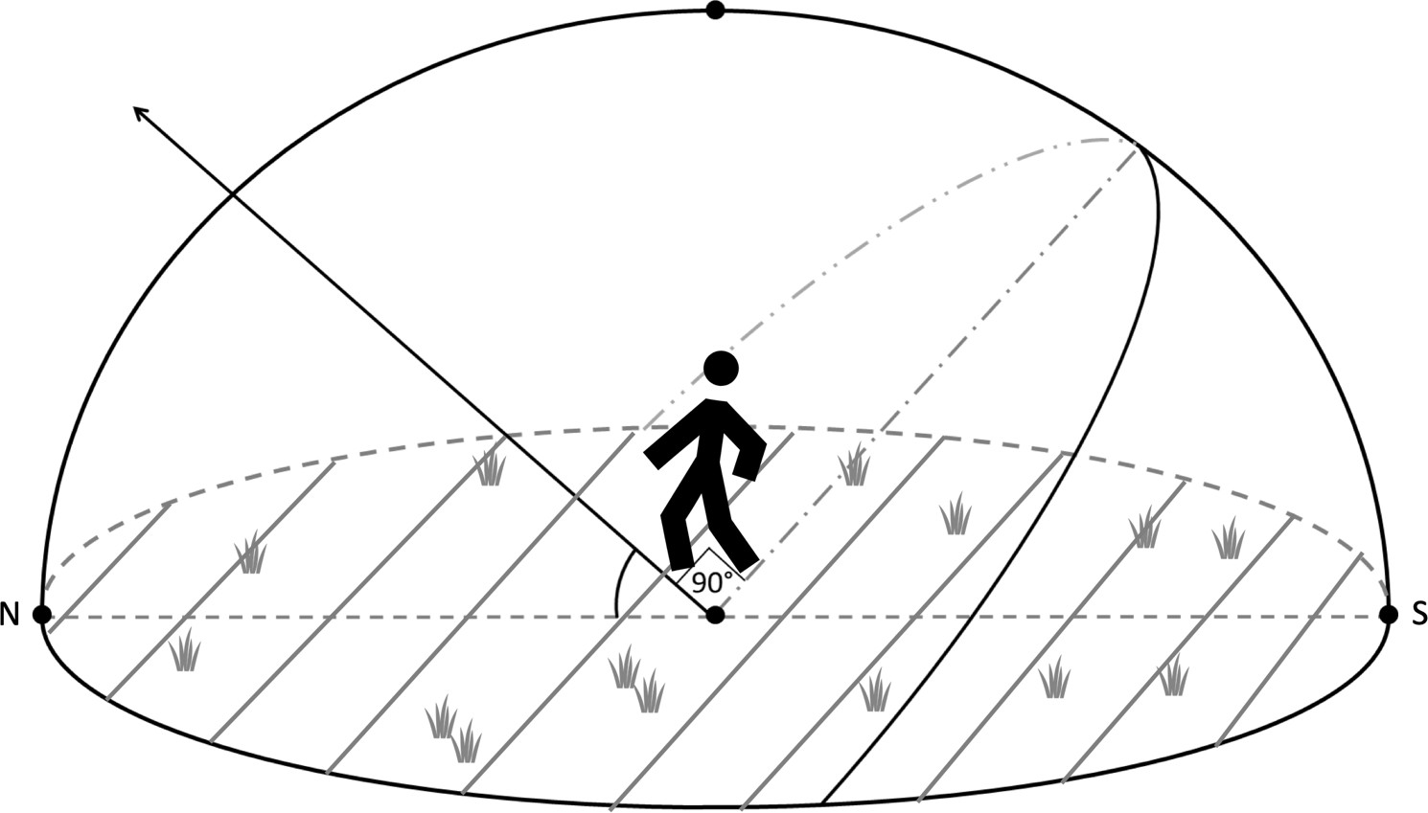
- A person stands outside beneath the dome of the night sky. Assume the diagram below is for Iowa City, which is at a latitude of ~42 degrees. Identify and label the following: the Celestial Equator, the North Celestial Pole, Zenith, the Meridian, the Horizon, and the cardinal directions North, South, East, and West along with their Azimuth Angle. Then draw where Polaris is and draw the path of a star over the course of one night.
- For Iowa City, what is the Sun’s elevation at noon on the Vernal Equinox? Mark it on the diagram above and include units in your answer.

Hint: Where is the general position of the Sun at noon (on the horizon, below the horizon, high in the sky, etc.)? Next, see the first figure from this lab in Question 1. You labeled the Sun’s exact position when the Vernal Equinox occurs. On that date, where the Sun is in relation to the Celestial Equator? Remembering the latitude of Iowa City, what is the height of the highest point of the celestial equator in Iowa City?

- For Iowa City, what is the elevation of the Sun at noon on the Summer Solstice? Mark it on the diagram above and include units in your answer.

Part 2: Introduction to Parallax

Make a fist and stick up your thumb, then hold out your hand at arm’s length and look at your thumb with one eye closed. Then close that eye and open the other. Did your thumb appear to move? This apparent displacement is called parallax and is useful for determining the distance to objects. In this part of the lab, we’ll calculate the distance to our thumb from our eyes when our arm is fully extended using parallax.

Consider the figure below. The observer, when they move from one position to a second different position, will perceive the star seen below at different places relative to the distant background, these different places separated by an angle θ. If the observer’s first position is a distance S from the observer’s second position, if the object is a distance D away, and if the distance D is much larger than S, then we can use the Small Angle Formula to relate S and D via the equations below.
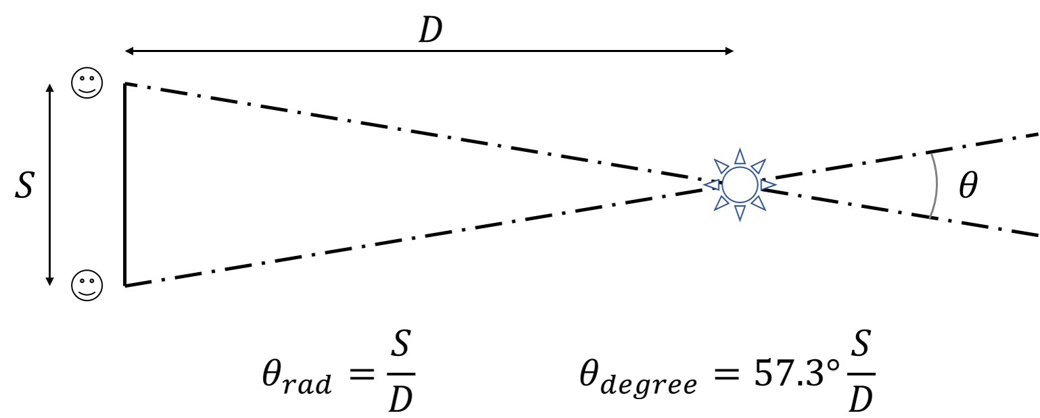

If we measure the angle θ and the distance S between the two observer positions, we can estimate the distance D to the object using the above formulas. The first formula works when measuring the angle in radians (which is unitless); the second formula works when θ is in units of degrees. There are 57.3º in one radian.

- What parallax angle θ in degrees does your thumb make when held at arm’s length when you close one eye and then the other? Include units in your answer.

- Measure the distance S between the two positions of the pupils of your eyes in centimeters. Record your answer below. Include units in your answer.

- Using your parallax angle θ, and the distance S between the pupils of your eyes, calculate the distance to your thumb in centimeters for this experiment. Make sure to use the proper formula for the units that you have!

- Measure the actual distance to your thumb using a meter stick. Compare the two values, the experimental value and the actual value, using the Percent Error Formula (linked at the top of the lab webpage for this lab, or found in the Glossary tab at the top left navigation bar of the lab webpage).

Part 3: Estimating Angles

In this part we’ll practice measuring the sky. The main point of this activity will be to estimate the azimuth, altitude, and angular size of a number of objects. The figure below is a handy guide for estimating angles with your hand when held at arm’s length.
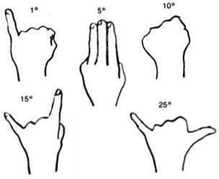

- Determine the direction North. Determine the direction of East. Describe how you would show someone the position of the meridian through the sky.

- Depending on the weather and your lab section, proceed to the proper section. Note the following definitions:

Azimuth – angle around the horizon, starting from North and increasing to the East. Ranges from 0° to 360°.

Altitude – angle above the horizon. Ranges from 0° at the horizon to 90° at the zenith.

Cloudy or Day Lab
For each of the following objects, estimate their azimuth angle and their angular size. Your TA will point out any objects that you need help identifying.

Object | Azimuth Angle | Angular Size
Hotel Vetro
Old Capitol Dome*
Grey Stone Church to the Northwest
VAO Telescope Dome†

* Just the dome at the top
† Viewed from the entrance to the roof.

Night Lab with Clear Skies
Your TA will point out several objects in the night sky. Record their names and estimate the various quantities.

Note: Remember, the altitude should not exceed 90º.

Object | Azimuth Angle | Altitude Angle

Object | Angular Size

Rainy or Cold Weather Lab: VAN 666
For each of the following objects, estimate their azimuth angle and their angular size. Your TA will point out any objects that you need help identifying.

Object | Azimuth Angle | Angular Size
Hotel Vetro
Tower Place Parking Ramp Clock Tower
VAN Lecture Halls Roof
Lab Room Door from Your Lab Table

Rainy or Cold Weather Lab: VAN 665
For each of the following objects, estimate their azimuth angle and their angular size. Your TA will point out any objects that you need help identifying.

Object | Azimuth Angle | Angular Size
Linn Street Crosswalk
Clock Tower Clock Face to the North
Grey Stone Church to the Northwest
Lab Room Door from Your Lab Table

