Names:

Grade

SIMBAD

Astronomical Database

Pre-Lab Quiz:
Record your answers as well as your reasonings and explanations.

1.
2.
3.
4.

Part 1: Classes of Objects to Explore

- Consulting Part 1 of the lab webpage for this lab and the table of Deep Sky Objects found there, decide on a broad class of object you would like to observe. What class of object did your group choose? Research and write the definition of this type of object below. What are the properties of this class of object? What physical processes go on in these types of objects?

- Decide on a specific example object(s) to study. Your objects can be taken from the table on the lab webpage, but they don't have to be. Which astronomical object(s) did your group select?

- Why was your group particularly interested in this broad class of object? This specific individual object(s)?

Part 2: Operations with SIMBAD

- What are the celestial coordinates (RA and Dec) of your object? In which constellation is this object located? (You’ll likely need to search for that final answer elsewhere on the internet.)

- See if there is a parallax measurement available for your object (there won’t be for all objects; some objects are too far away). If there is, calculate the distance d in parsecs as described on Part 2 of the lab webpage for this lab. Show your work below. Think about your answer in the context of what you have studied in your Astronomy class, i.e., the distances to the nearest stars, the distance to the Galactic Center, etc.

- Expand the image window on your object and look at it. Look at it in more than one survey, if possible, and zoom in and out. What is the angular diameter of your object in arcseconds, arcminutes, or degrees, whichever unit is best suited for your object? Show your work below. (Note that this is not possible if you selected a star; stars appear as saturated points and SIMBAD cannot give information on their angular diameter.)

- If you were able to obtain both a distance d in parsecs for your object and an angular diameter in the declination coordinate in arcseconds, arcminutes, or degrees, use the relevant version of the Small Angle Formula below to calculate the physical diameter D of your object. Show your work below. 1° (deg, degrees) =
60' (arcmin, arcminutes) = 60" (arcsec, arcseconds).
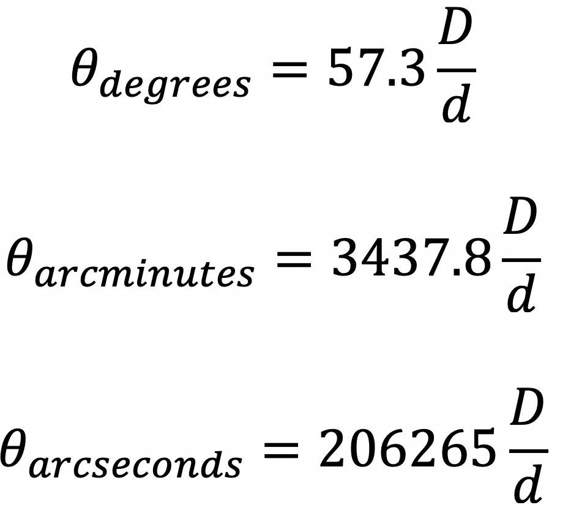

- What if anything do you notice in the image of your object that matches with the properties of its class of object you identified in Part 1, Question 1? Do you see any evidence of the physical processes that go on in these types of objects? The purpose of this question is to see if you can make a connection between textbook descriptions of these types of objects and what you can observe with a powerful astronomical telescope. (If you chose a star for your object of interest, some of this may be harder to answer. Still possibly record anything you notice in the image of the star.)

- Draw a sketch of your object here (either draw in a computer application or draw on a piece of paper and then take a photo to include in your lab). Illustrate the features of your image that most strike you.

