Names:

Grade

Image Analysis II

Pre-Lab Quiz
Record your team's answers as well as your reasonings and explanations.

1.
2.
3.
4.

Part 1: Determining the Motion of the Asteroid 3 Juno
The image below is a combined image of two images of the Asteroid 3 Juno taken at the Iowa Robotic Observatory at 5:46:00 and 8:00:00 UT on 2015 April 15. Note that the horizonal and vertical angular distances traveled are recorded on the image.
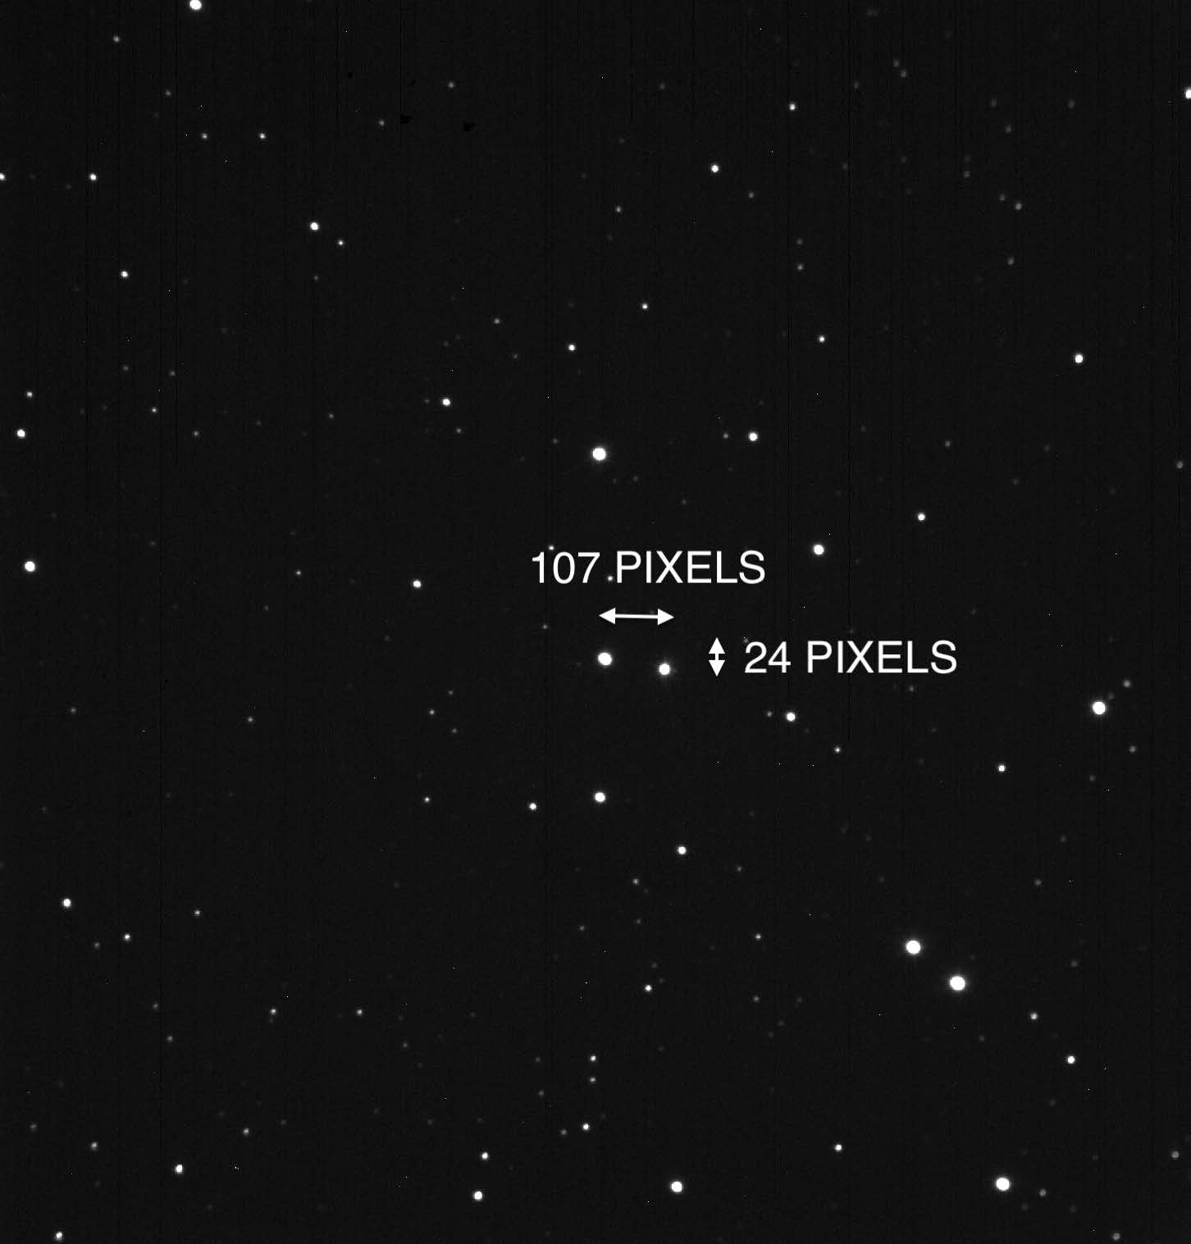

1. What is the angular distance (in pixels) that the asteroid traveled from one image to the next? Record the horizontal ($∆$x) and vertical ($∆$y) shifts, as well as the total number of pixels traveled.

$∆$x | $∆$y | Total

2. If the asteroid was 3.1x10¹¹ meters away when the image was taken, how far did the asteroid travel in km between the two images?
Note: The pixel scale for this image is 1" / pixel.

3. Determine the time between the two images. What is the speed of the asteroid in km / s?

4. The semi-major axis of 3 Juno’s orbit is 2.67 AU. How long does it take to complete one orbit around the Sun?
Hint: Think about Kepler’s three laws.

Part 2: Determining the Motion of Comet Garradd
The image below is a combined image of two images of Comet Garradd taken at the Iowa Robotic Observatory at 2:53:00 and 4:02:00 UT on 2011 October 11. Note that the horizonal and vertical angular distances traveled are recorded on the image.
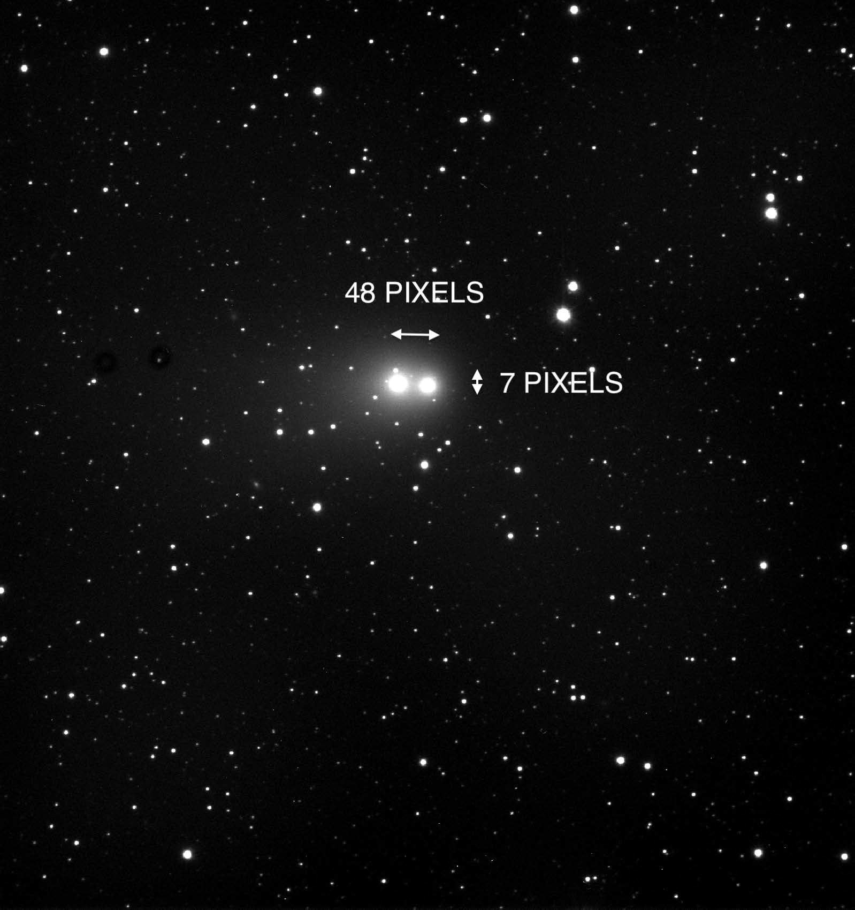

1. What is the angular distance (in pixels) that the comet traveled from one image to the next? Record the horizontal ($∆$x) and vertical ($∆$y) shifts, as well as the total number of pixels traveled.

$∆$x | $∆$y | Total

2. If the comet was 2.7x10¹¹ meters away when the image was taken, how far did the comet travel in km between the two images?
Note: The pixel scale for this image is 1" / pixel.

3. Determine the time between the two images. What is the speed of the comet in km / s?

4. What assumption(s) did you make when calculating the speed that might cause you to misestimate the true speed of the comet?

