Names:

Grade

Introduction to Spectroscopy

Pre-Lab Quiz
Record your team’s answer as well as your reasonings and explanations.

1.
2.
3.
4.

Part 1: Visible Light
- For the spectrum of each light in the black box shown below, record the color and minimum, maximum, and peak wavelengths λ.
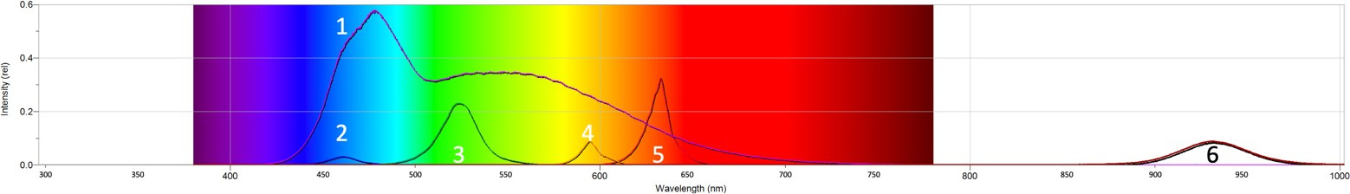

Bulb | Color | λmin (nm) | λpeak (nm) | λmax (nm)
1
2
3
4
5
6
- What type of light is light #6 and why does it not appear to light up?

- Why is the range of wavelengths for white light so large compared to the other single colors?

Part 2: Color and Temperature
- For each type of light bulb (LED (A), fluorescent (B), incandescent (C)), describe and explain the appearance of the light of the bulb’s spectrum shown below. Determine whether it is a continuous or an emission line spectrum.

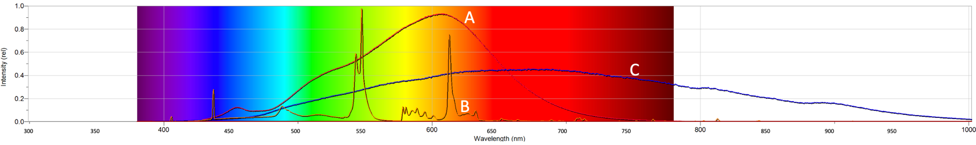

 | Description | Continuous or  Emission Line?
LED (A)
Fluorescent (B)
Incandescent (C)

- Calculate the temperature of the incandescent bulb using Wien’s law. Show your work and include units in your answer.

- From the spectrum of the Sun shown below, estimate its temperature using Wein’s law. Show your work and include units in your answer. Compare the temperature and color of the Sun to that of the incandescent light bulb.
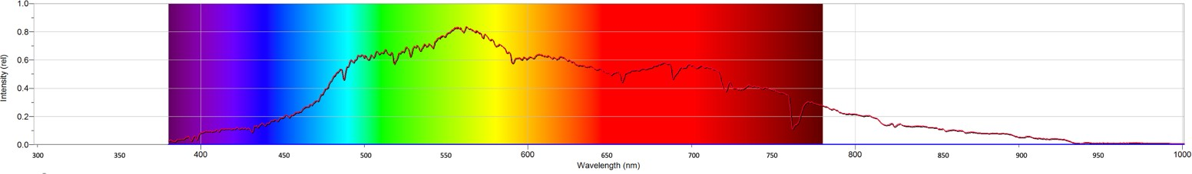

- Why are there dips in the Solar spectrum?

Part 3: Analyzing Emission Spectra
- Examine the spectra of hydrogen and helium shown below. For each sample, record the wavelength and color of the strongest lines ranked on their relative strengths (1 = strongest, 2 = next strongest, and so on).
Hydrogen (H) – three strongest emission lines
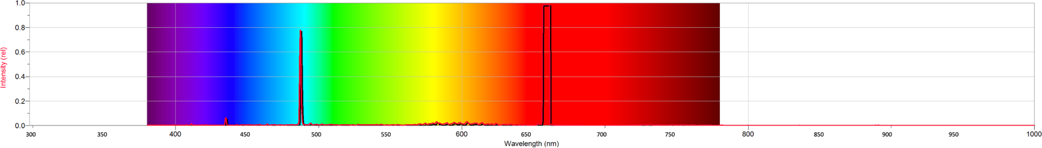

Line (Transition) | Relative Strength | λpeak (nm) | Color
Hα (3 2) | 1
Hβ (4 2) | 2
Hγ (5 2) | 3

Helium (He) – five strongest emission lines
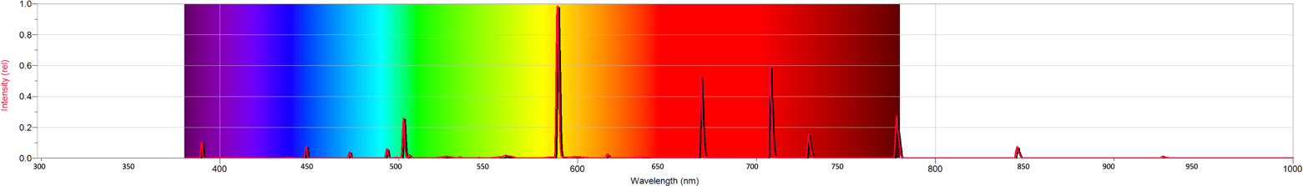

Relative Strength | λpeak (nm) | Color
1
2
3
4
5

- Examine the spectrum of air below.
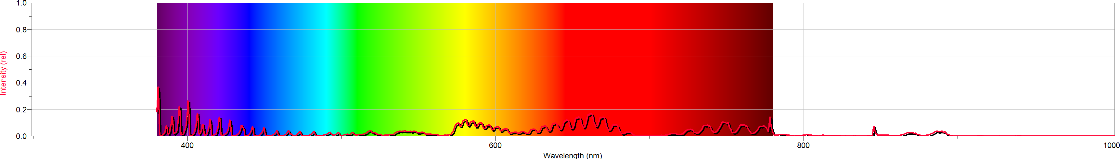
Air contains hydrogen, helium, neon (Ne), argon (Ar), carbon dioxide (CO₂), and nitrogen (N), all six elements, in varying amounts. Review the spectra of hydrogen and helium above and examine the spectra of neon, argon, carbon dioxide, and nitrogen below.
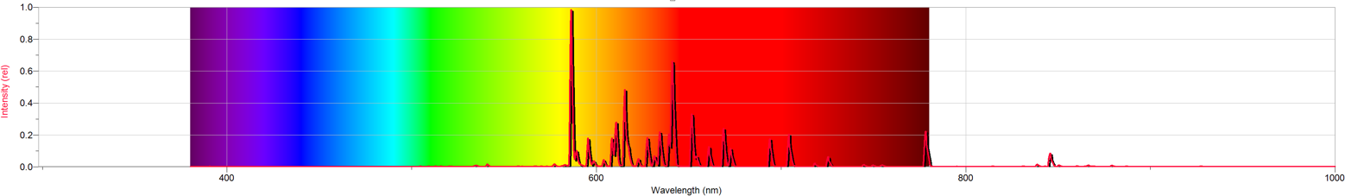
Neon (Ne)
Argon (Ar)
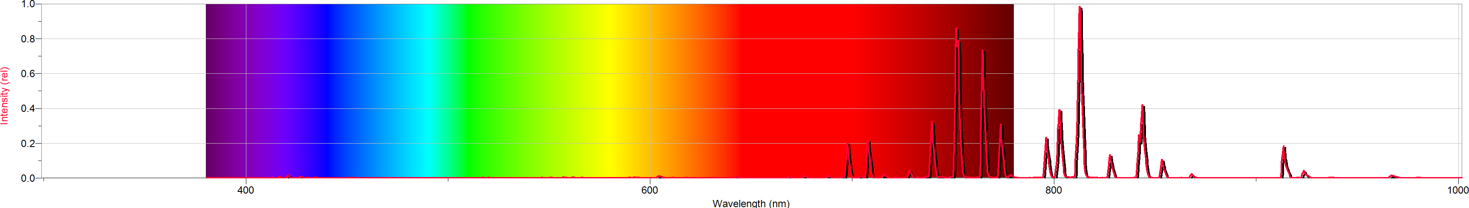
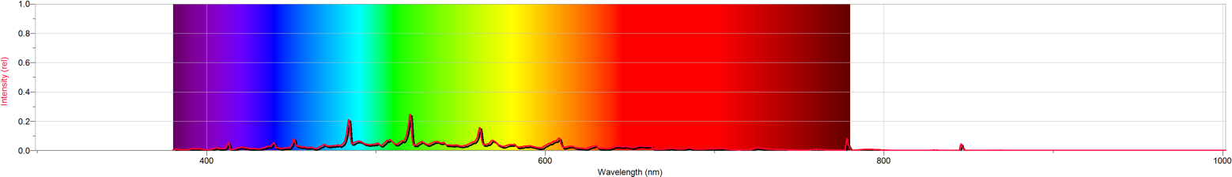
Carbon Dioxide (CO₂)
Nitrogen (N)
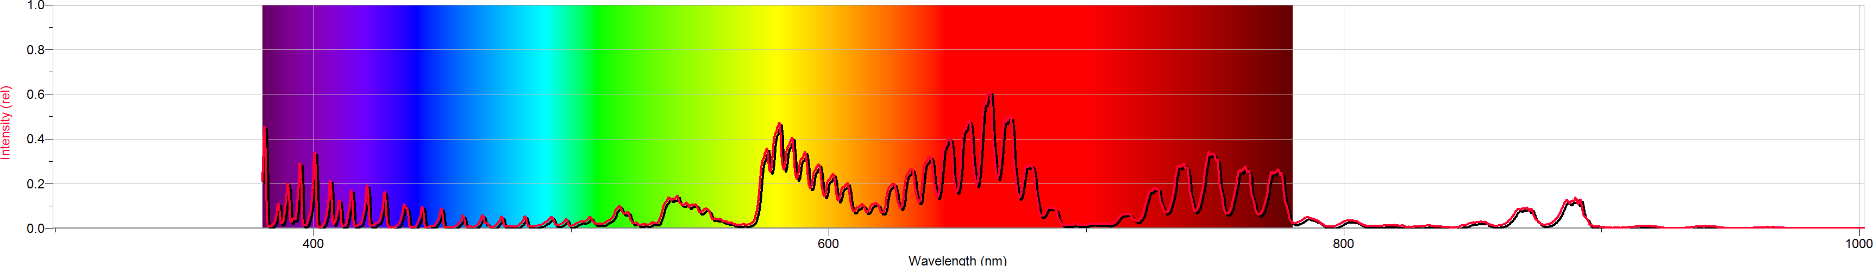
Which one of these six elements is found in air in the greatest abundance? Explain your answer.

