Names:

Grade

The Mass of Jupiter

Pre-Lab Quiz
Record your team’s answers as well as your reasonings and explanations.

1.
2.
3.
4.

Part 1: Identifying the Galilean Moons
Using the Iowa Robotic Observatory telescope, Jupiter has been imaged five times over a two-day period of time (note the timestamps in the lower right of the images in the figure below).
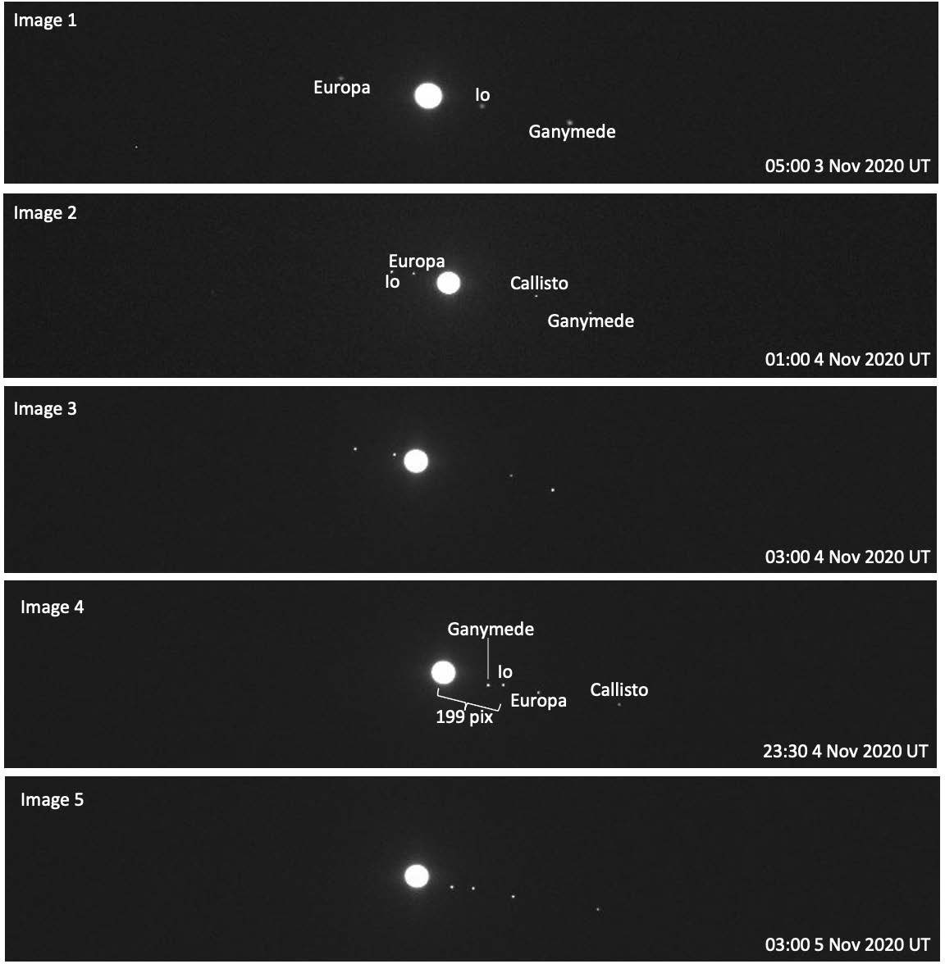

- In the images provided, as time passes, why do the Galilean moons appear to move along a line from upper left of the images to bottom right of the images? (Why don’t the
moons orbit around Jupiter in a circle (ellipse) as if you're viewing everything from above?)

- Using Stellarium Web or the Find Jupiter's Moons App linked on the lab webpage for this part of the lab, identify each of the four Galilean moons shown in Image 3 and Image
5. For each image, you can either label the moons on the figure on the previous page or list the names of the moons below in order of appearance from left to right.

- In Image 1, why do you think the fourth Galilean moon, Callisto, is not labeled or pictured?

- Between the times Image 1 and Image 4 were taken, Jupiter’s moon Io completed exactly one full orbit around Jupiter. What is P, the orbital period of Io, the time it takes to go around Jupiter once, in hours, days, and Earth years?

P (hr)
P (days)
P (yr)

- As Io was imaged as it orbited Jupiter, the imaging time of Image 4 was noteworthy. This is because at this time, Io was at the furthest right of Jupiter of any other time in its orbit. Because of this, Image 4 can be used to identify a, Io’s semi-major axis, or average distance from Jupiter. In Image 4 above, a is given in pixels. Noting that the pixel scale of the image is 0.54”/pix, what is a in arcseconds?

Part 2: Applying Kepler’s Law
  - Researching or remembering the distance between the Earth and the Sun and Jupiter and the Sun in in astronomical units (AU, or the average Earth to Sun distance), what is a rough approximation of d, the distance from Earth to Jupiter at the time of your images in AU? Then use Stellarium Web or the Find Jupiter's Moons App linked on the lab webpage for this part of the lab to find this exact value at the time these images were taken. Note that the Iowa Robotic Observatory
is located near Tucson, AZ, which is on Mountain Time and in November is at
UT-6 hours.

  - Using d in AU from Question 1, a in arcseconds from Question 5 in the previous part of this lab, and the rearranged version of the Small Angle Formula below, determine Io’s semi- major axis a in astronomical units, AU.

$$a_{AU}=\frac{d×a_{arcseconds}}{206265}$$

  - Using a in AU from Question 2, P in Earth years from Question 4 in the previous part of this lab, and the version of Kepler’s Law below, determine the mass of Jupiter M in solar masses, M_{Sun}.
Note: In order for this version of Kepler’s Law to apply, where M is returned in M_{Sun},
a must be in AU and P must be in Earth years.

$$M=\frac{a^{3}}{P^{2}}$$

  - What is the mass of Jupiter M, not relative to the Sun in solar masses, M_{Sun}, as before, but relative to the Earth in Earth masses, M_{Earth}?
Note: 332,900 M_{Earth} = 1 M_{Sun}.

