Names:

Grade

Hertzsprung-Russell Diagram
&

Star Clusters

Pre-Lab Quiz
Record your team’s answers as well as your reasonings and explanations.

1.
2.
3.
4.

Part 1: The H-R Diagram
We’ll be using magnitudes for much of today’s lab. Note that B and V represent the apparent magnitude in the blue and green (visual) photometry bands respectively.
- Does a greater V magnitude imply that a star is brighter or fainter?

- Does a larger B – V color imply that a star is bluer or redder?

- On the H-R diagram below (a plot of observed stars in our galaxy) indicate:
  - the direction of increasing temperature
  - the direction of increasing luminosity
  - the location of the Main Sequence, Giants, Supergiants, and White Dwarfs
  - the location of the Sun (B – V = 0.65, MV =4.83)
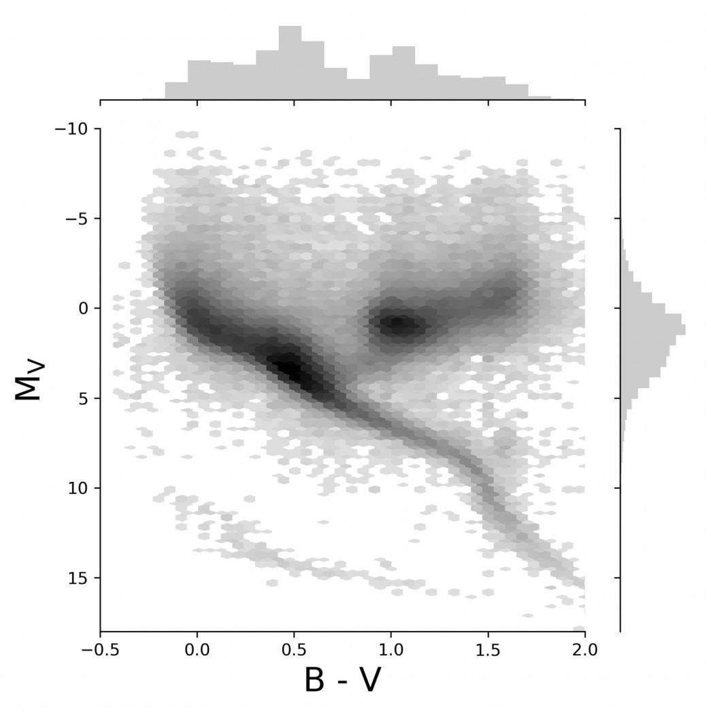

4) Click on the "NAAP Labs" link on the lab computers (in-person labs), clicking through to "9. H-R Diagram" and "H-R Diagram Explorer". (For online labs, click the “H-R Diagram Mobile” link on the lab website for this lab.) Using the application, estimate the various quantities for each of the stars below.
Note: The temperature estimates using the B – V color generally don’t work very well for white dwarfs. Thus your temperature estimate for the white dwarf will be smaller than the actual value.

Star | Arcturus | Deneb | α Centauri A | Sirius B
B – V | +1.23 | +0.09 | +0.71 | -0.03
MV | -0.30 | -8.38 | +4.38 | +11.18
Spectral Type
T (K)
L* (L_{Sun})
R* (R_{Sun})
Luminosity Class
- What spectral type of star is most common in the Solar neighborhood?

- Why is the most common type of star in the Solar neighborhood not also the most abundant type of star on the H-R diagram from Problem 3?
Note: Plotting the brightest stars in our galaxy may give you a clue.

Part 2: Globular Clusters

- What are globular clusters?

- Draw an edge-on schematic of the Milky Way Galaxy in the space below and indicate where the globular clusters are located. Label the bulge, disk, and halo components.

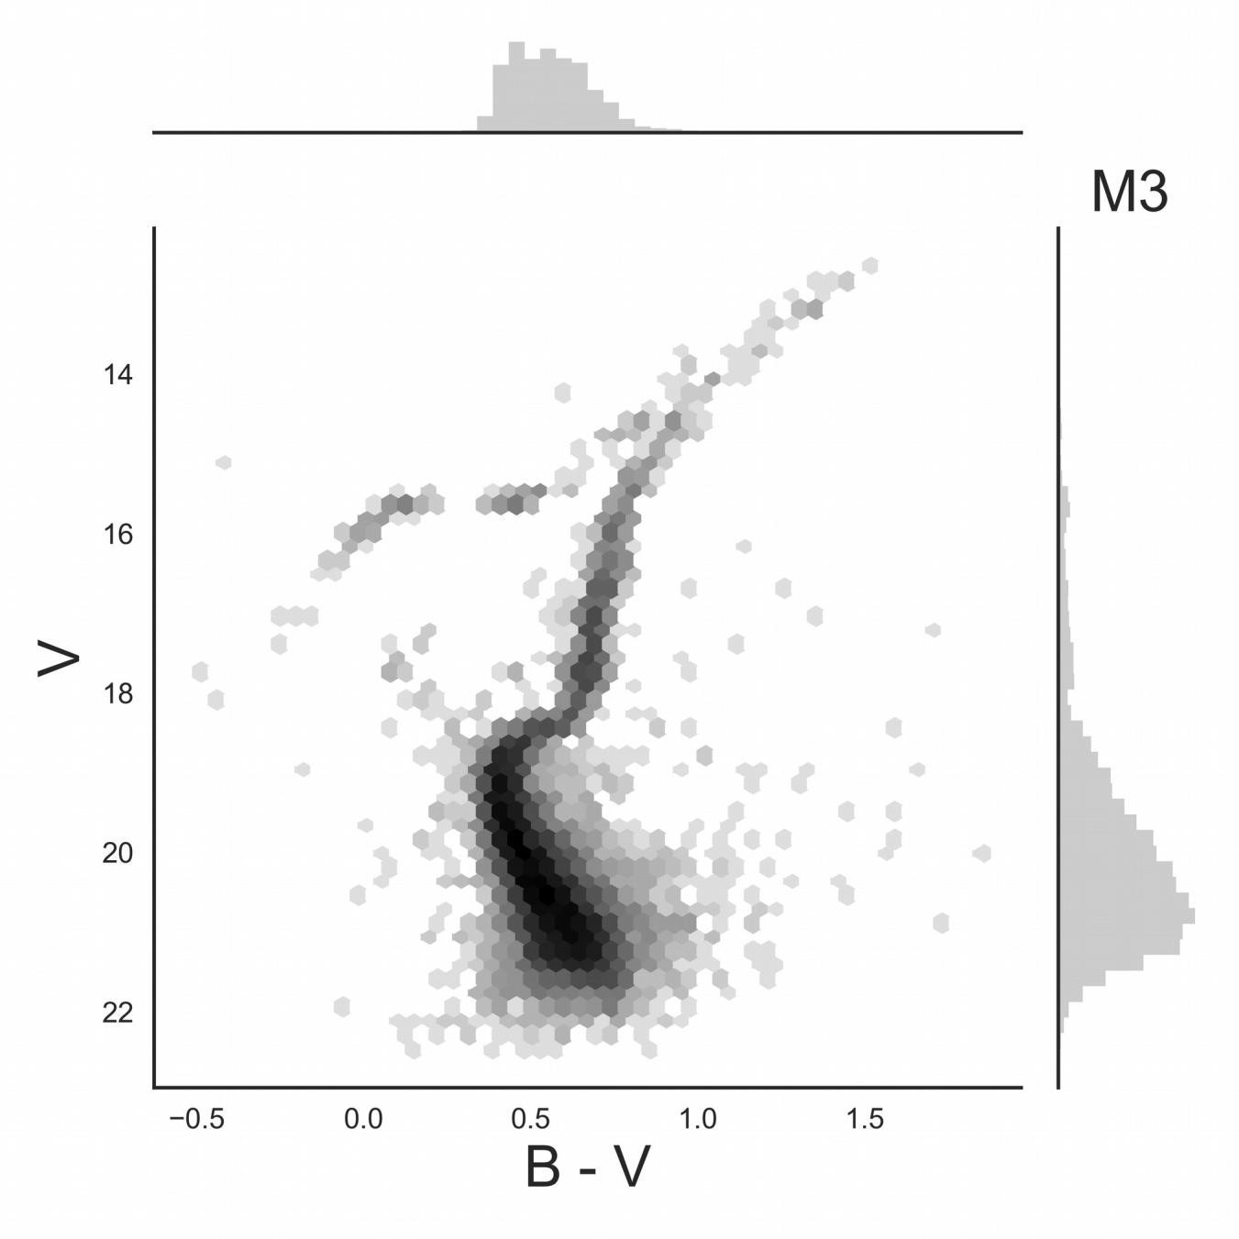
- For the HR Diagram of the globular cluster M3 below, label the main sequence (MS), the main sequence turnoff point (TP), the giant branch (GB), the horizontal branch (HB).
- What spectral type of stars are currently turning off of the main sequence in this globular cluster? Using the B – V color associated with the TP and the plot on Part 2 of the lab website.

B – V |  | Spectral Type

- If stars of this spectral type are currently turning off of the main sequence, how old must these stars (and all of the stars in the globular cluster) be? (Determine the age of the globular cluster using the TP.) Explain your answer.

- Examine the HR Diagrams of the four clusters on the website and rank them from youngest to oldest.

 | TP | Spectral Type | Age (years) | Age Rank  (1 = Youngest,  4 = Oldest)
M67
Pleiades
M71
M2
Explain your rankings.

- If a star cluster is at a distance from us, there would be clouds of dust between us and the cluster. How would this change the observed V magnitude and B – V color?
Note: Dust particles preferentially scatter blue light.

