Names:

Grade

Solar Observations

Pre-Lab Quiz:
Record your answers as well as your reasonings and explanations.

1.
2.
3.
4.

Part 1: Features of the Sun

- Pick two types of images of the Sun to study from the following options: white light
images (Big Bear Solar Observatory, BBSO), magnetic field pattern images (Solar Dynamics Observatory (SDO), sometimes available through BBSO), ultraviolet light images (Solar Heliophysics Observatory (SoHO), SDO), and coronagraph images (SoHO). Write your two selections below, noting that if you chose ultraviolet light images as one of your image types you should pick a specific wavelength in Angstroms as part of your choice and write this below (for example, SoHo’s ‘EIT 195’ (A) or SDO’s ‘AIA 211 A’). In the last questions of this lab you will also study what the Sun looks like in Hex light, either from using a Solar telescope on the roof or from using the Big Bear Solar Observatory.

- Describe the disk of the Sun as it appears in the first type of image your group chose, noting anything that strikes you as noteworthy or interesting. You should note which Solar features you think you can see, and also specifically state what phenomena where not present in your images and why you think this is. Also note the day and time the image was taken. (The BBSO, SoHO, and SDO usually display images in real time/near-real time, but this is not always the case, so this is important information to note. Furthermore, note that if you came back to observe the Sun again tomorrow, or next week, these images would all look different.)

- Draw the Sun as it appears in the first type of image you chose on the diagram below. Label features and record their locations as accurately as you can.
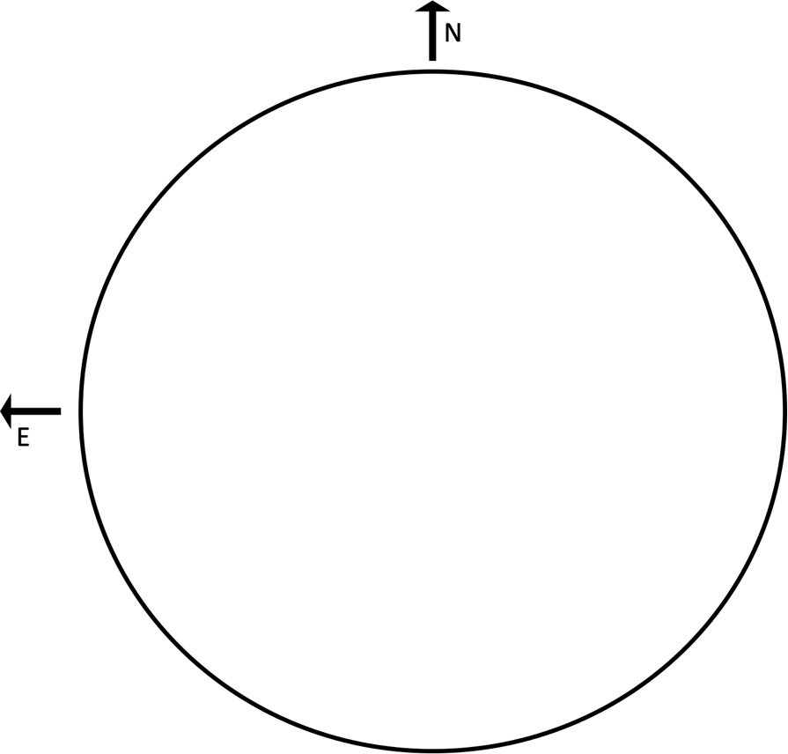

- Describe the disk of the Sun as it appears in the second type of image your group chose, noting anything that strikes you as noteworthy or interesting. You should note which Solar features you think you can see, and also specifically state what phenomena where not present in your images and why you think this is. Also note the day and time the image was taken.

- Draw the Sun as it appears in the second type of image you chose on the diagram below. Label features and record their locations as accurately as you can.

- Compare and contrast what you saw when looking at the two types of images.

- Draw the Sun as it appears in Ha light on the diagram below, either through one of the Solar telescopes on the roof or from using the Big Bear Solar Observatory, at your TA’s direction. Label features and record their locations as accurately as you can. Also note the day and time of your observation or the day and time the image was taken.

- Compare and contrast what you saw when looking at the Sun in Ha light with what you saw in your images in Questions 2 and 4.

