Names:

Grade

Observing with the VAO

Pre-Lab Quiz
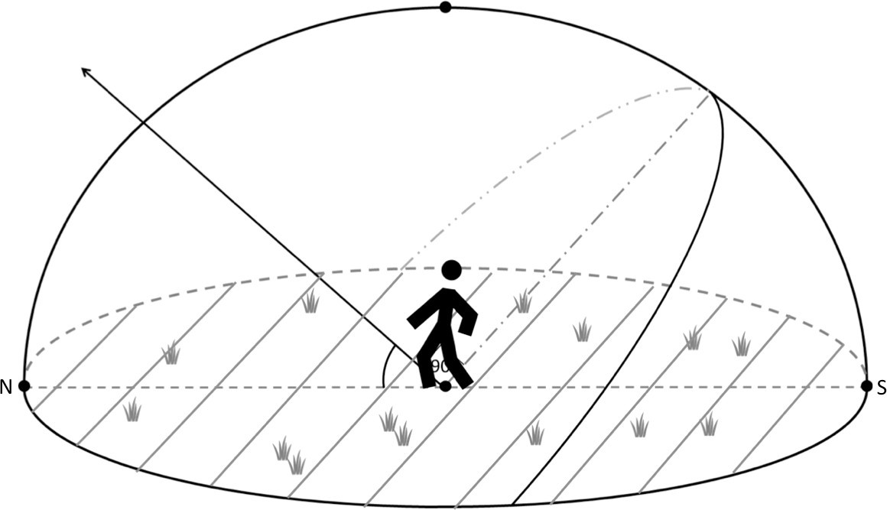Record your team’s answers as well as your reasonings andexplanations. 1-4.

Part 1: The VAO and Target Selection
- What kind of telescope is the Van Allen Observatory? Is this a reflecting or refracting telescope? Roughly sketch how light goes through this telescope to be focused on the camera.

- Research the objects on the list of candidate targets, picking to be your final observation target. What did you select? Write a brief summary about it below, including details about its appearance.

Part 2: Selecting a VAO Filter

- For each filter on the VAO given on the lab webpage, report its wavelength coverage (the starting and ending wavelengths). Is this filter a broadband or
narrowband filter? Also approximate the central wavelength of the filter. What color of light does this filter correspond to in the electromagnetic spectrum?

Filter Name | Wavelength  (nm) | Range | Filter Type | Central Wavelength  (nm) |  | Color
R
G
B
H-alpha

- Why does the VAO have filters?

- Choose a filter(s) to observe your final observation target in and list it below.

Part 3: CCDs and Selecting an Exposure Time

- What is the pixel size of the CCD camera on the VAO? Compare this value to the widths of human hairs, whose diameters fall in the range of 20-200 microns (μm).

- For an observatory, what does field of view (FOV) mean? What is the field of view of the Van Allen Observatory?

- Select an exposure time for your final observation target and fill out the table below.

Final  Observation Target | RA | Dec | Filter Choice(s) | Exposure  Time Selection(s)

