Names:

Grade

Angular Size

Pre-Lab Quiz
Record your team’s answers as well as your reasonings and explanations.

1.
2.
3.
4.

Part 1: Equations of Angular Size
- In the picture at the bottom of the lab webpage for this part of the lab, which side of the building displayed is the opposite side of the tangent relationship (H or D)? Which side is the adjacent side?

- Suppose the height of the building is 52 feet tall, and suppose that 8 is 65°. Does the SmallAngle Formula apply in this instance? Why or why not?

- Calculate the distance to the building, D, and show your work and include units in your answer. Use the Small Angle Formula if it applies.

- Each of your lab partners should go outside and try to find the Moon where you are located. As many group members as are able (depending on weather, building/tree obstruction) should estimate the azimuth, altitude, and angular size of the Moon and record this information below, referencing the diagram and definitions provided.
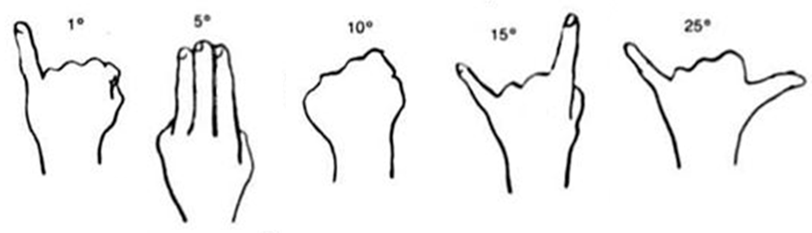
Azimuth – angle around the horizon, starting from the North and increasing to the East. Ranges from 0° to 360°. (Use a resource such as Google Maps to locate North, East where you are.)
Altitude – angle above the horizon. Ranges from 0° at the horizon to 90° at the zenith.

- Which side of the face of the Moon is illuminated today (the left or the right)? By about how much? (Use Stellarium Web if it is cloudy.) From that information and information from lecture, what is the current phase of the Moon?

- From the approximate angular size of the Moon you found, can the Small Angle Formula be applied? Why or why not?

- The physical diameter of the Moon is about 3474 km. Calculate the distance to the Moon with these numbers, and show your work and include units in your answer. Use the Small Angle Formula if it applies.

Part 1: Finding Distances
If you are in ASTR:1070/1079 Stars, Galaxies, and the Universe or ASTR:1772, skip questions 1, 2, and 3 (complete questions 4-10).

If you are in ASTR:1080 Solar System Astronomy or ASTR:1771, skip questions 8, 9, and 10 (complete questions 1-7).

The image below is color-combined R, G, and B filter image of the planet Neptune taken at the Van Allen Observatory. Note that the angular size of Neptune in pixels is recorded on the image.
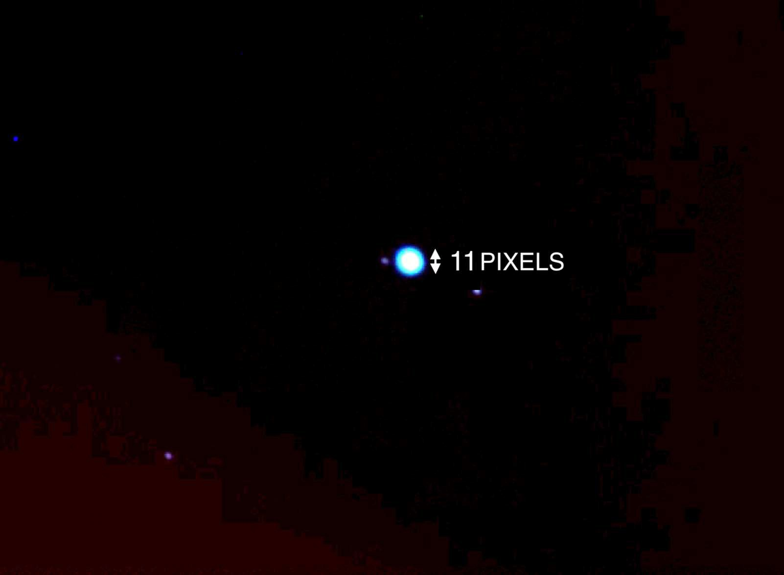

- If Neptune is 0.00033 astronomical units (AU) in diameter, how far away is Neptune in AU? Note the rearranged Small Angle Formula below, note the pixel scale of the image is 0.63” / pix, and use the table below to guide your work.

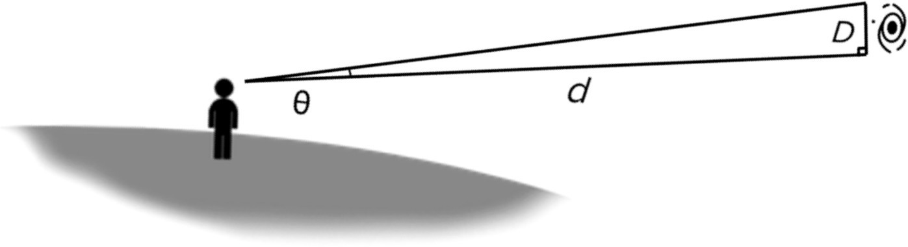

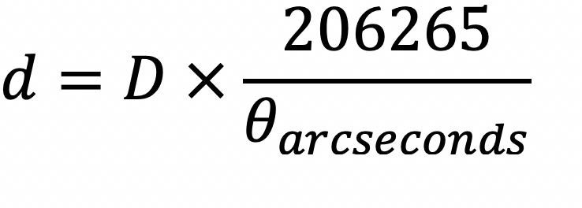

0 in pixels
0 in ” (arcseconds)
D (physical size of the object)
d (distance to object being observed)

- What is the name of Neptune's largest moon? What is its orbital period in days (how many days does it take the moon to travel around Neptune once)?

- What constellation(s) is Neptune in, currently? Currently, what time(s) of year is this object visible in the night sky?

The image below is color-combined R, G, and B filter images of the planetary nebula M57 (The Ring Nebula) taken at the Iowa Robotic Observatory. Note that the angular size of the Ring Nebula in pixels is recorded on the image.

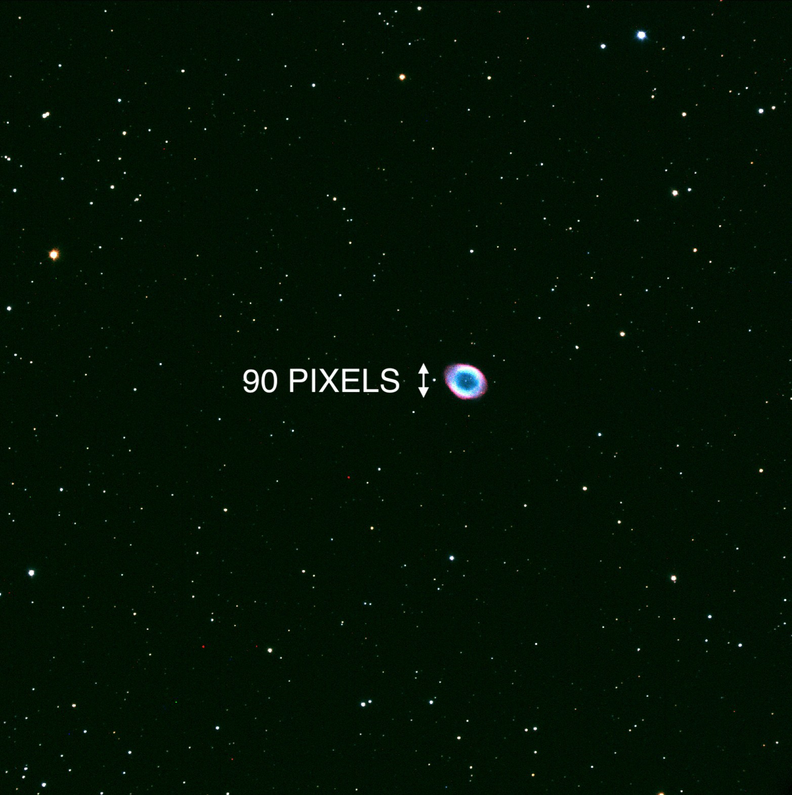

- If planetary nebulae are typically 0.1 light years (ly) in diameter, how far away is the Ring Nebula located in ly? Note the rearranged Small Angle Formula below, note the pixel scale of the image is 0.73” / pix, and use the table below to guide your work.

0 in pixels
0 in ” (arcseconds)
D (physical size of the object)
d (distance to object being observed)

- What type of objects form planetary nebulae like the Ring Nebula? Describe this process.

- What is the surface temperature of the object at the center of the Ring Nebula? What type of star is this object?

- What constellation(s) is the Ring Nebula located near? What time(s) of year is this object visible in the night sky?

The image below is color-combined R, G, and B filter images of the spiral galaxy M51 (The Whirlpool Galaxy) taken at the Iowa Robotic Observatory. Note that the angular size of the Whirlpool Galaxy in pixels is recorded on the image.
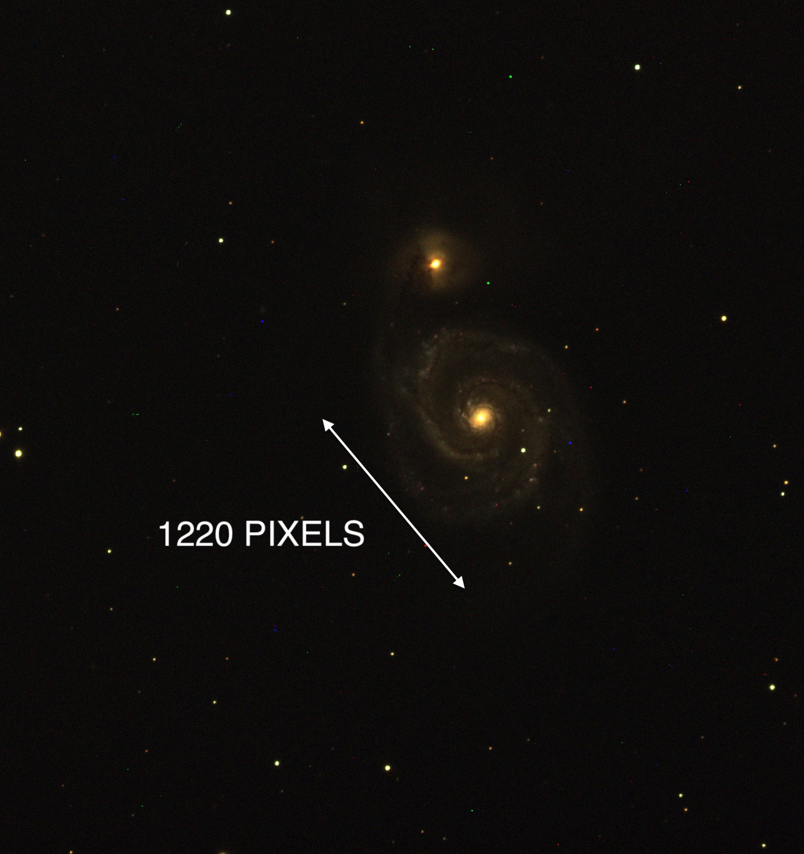

- If galaxies are 0.1 million light years (Mly) in diameter on average, how far away is the Whirlpool Galaxy located in Mly? Note the rearranged Small Angle Formula below, note the pixel scale of the image is 0.73” / pix, and use the table below to guide your work.

0 in pixels
0 in ” (arcseconds)
D (physical size of the object)
d (distance to object being observed)

- What type of galaxy is our Solar System located in?

- What constellation(s) is the Whirlpool Galaxy located near? What time(s) of year is this object visible in the night sky?

