Names:

Grade

Angular Size

Pre-Lab Quiz
Record your team’s answers as well as your reasonings and explanations.

1.
2.
3.
4.

Part 1: Equations of Angular Size
- In the picture at the bottom of the lab webpage for this part of the lab, which side of the building displayed is the opposite side of the tangent relationship (H or D)? Which side is the adjacent side?

- Suppose the height of the building is 52 feet tall, and suppose that θ is 65°. Does the Small Angle Formula apply in this instance? Why or why not?

- Calculate the distance to the building, D, and show your work and include units in your answer. Use the Small Angle Formula if it applies.

- Now suppose that you are looking at the Moon. From the main page for this Angular Size lab, what is the approximate angular size of the Moon? Does the Small Angle Formula apply in this instance? Why or why not?

- The physical diameter of the Moon is about 3474 km. Calculate the distance to the Moon with these numbers, and show your work and include units in your answer. Use the Small Angle Formula if it applies.

Part 1: Finding Distances
If you are in ASTR:1070/1079 Stars, Galaxies, and the Universe or ASTR:1772, skip questions 1, 2, and 3 (complete questions 4-10).

If you are in ASTR:1080 Solar System Astronomy or ASTR:1771, skip questions 8, 9, and 10 (complete questions 1-7).

The image below is color-combined R, G, and B filter image of the planet Neptune taken at the Van Allen Observatory. Note that the angular size of Neptune in pixels is recorded on the image.
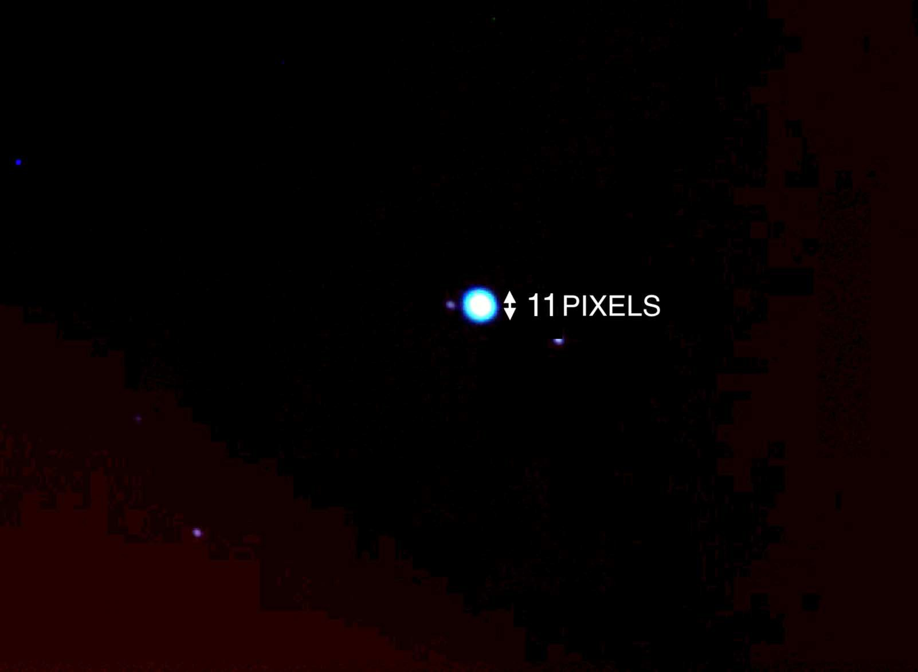

- If Neptune is 0.00033 astronomical units (AU) in diameter, how far away is Neptune in AU? Note the rearranged Small Angle Formula below, note the pixel scale of the image is 0.63” / pix, and use the table below to guide your work.

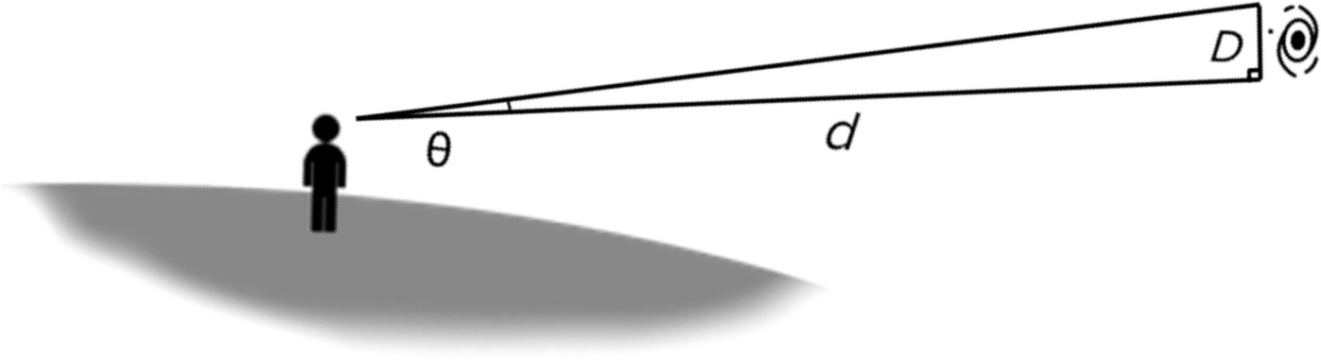

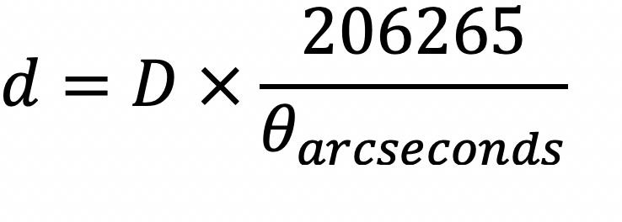

θ in pixels
θ in ” (arcseconds)
D (physical size of the object)
d (distance to object being observed)

- What is the name of Neptune's largest moon? What is its orbital period in days (how many days does it take the moon to travel around Neptune once)?

- What constellation(s) is Neptune in, currently? Currently, what time(s) of year is this object visible in the night sky?

The image below is color-combined R, G, and B filter images of the planetary nebula M57 (The Ring Nebula) taken at the Iowa Robotic Observatory. Note that the angular size of the Ring Nebula in pixels is recorded on the image.

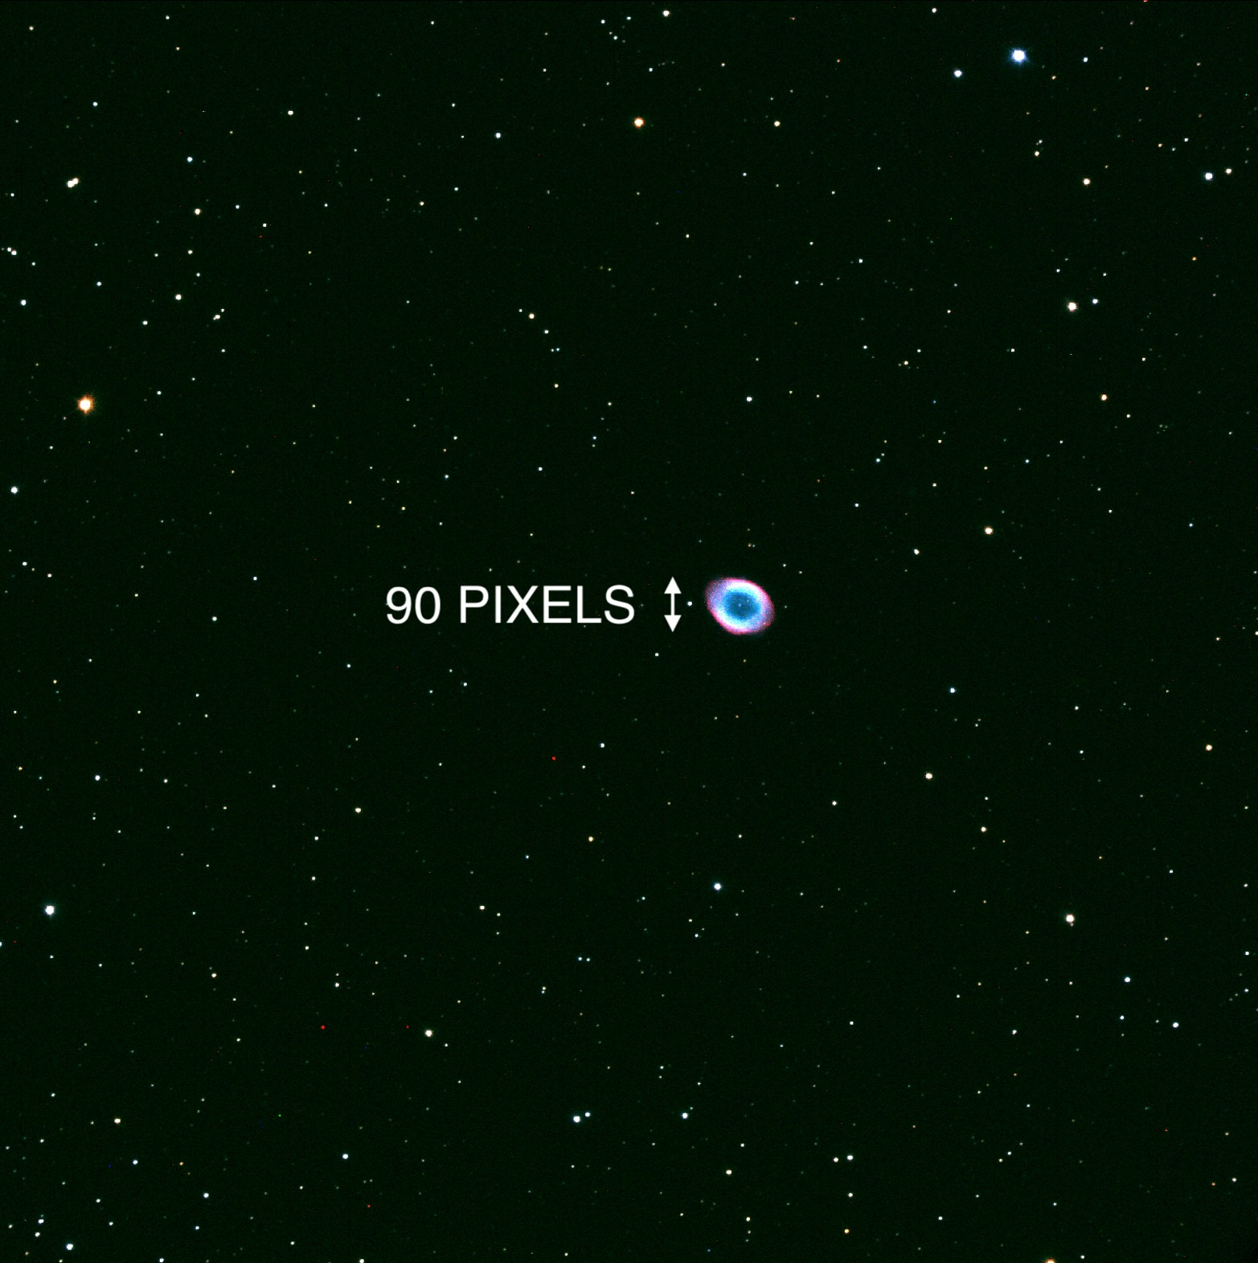

- If planetary nebulae are typically 0.1 light years (ly) in diameter, how far away is the Ring Nebula located in ly? Note the rearranged Small Angle Formula below, note the pixel scale of the image is 0.73” / pix, and use the table below to guide your work.

θ in pixels
θ in ” (arcseconds)
D (physical size of the object)
d (distance to object being observed)

- What type of objects form planetary nebulae like the Ring Nebula? Describe this process.

- What is the surface temperature of the object at the center of the Ring Nebula? What type of star is this object?

- What constellation(s) is the Ring Nebula located near? What time(s) of year is this object visible in the night sky?

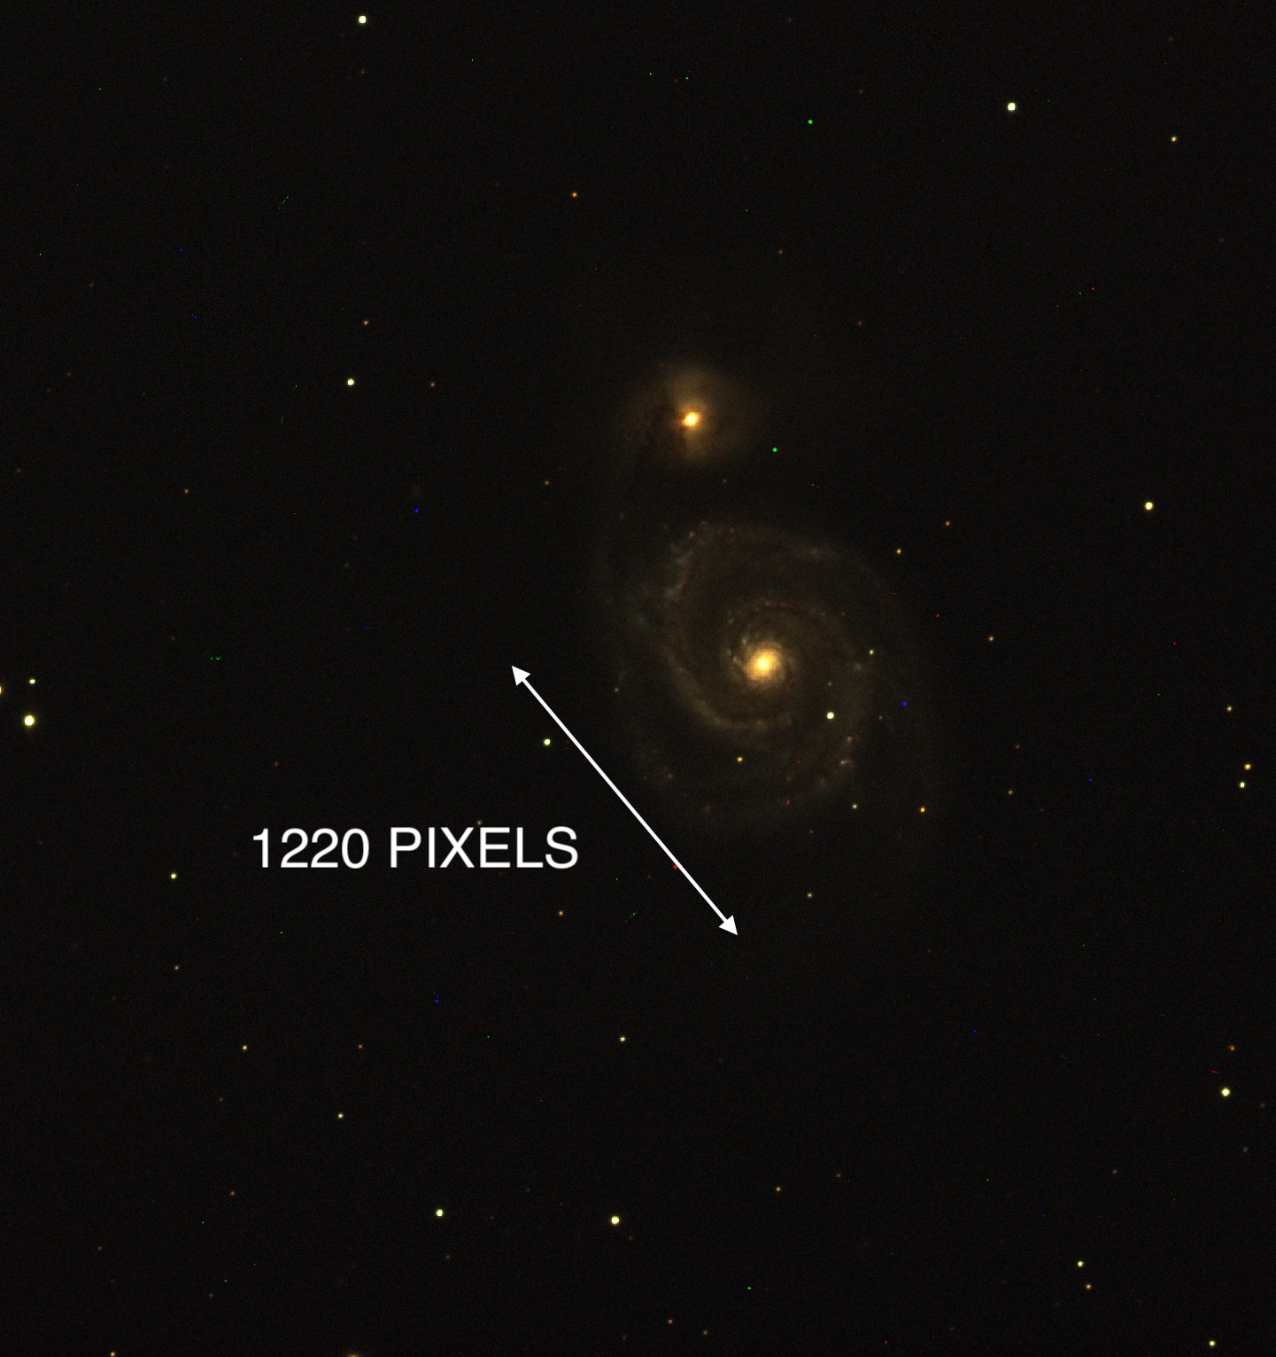
The image below is color-combined R, G, and B filter images of the spiral galaxy M51 (The Whirlpool Galaxy) taken at the Iowa Robotic Observatory. Note that the angular size of the Whirlpool Galaxy in pixels is recorded on the image.

- If galaxies are 0.1 million light years (Mly) in diameter on average, how far away is the Whirlpool Galaxy located in Mly? Note the rearranged Small Angle Formula below, note the pixel scale of the image is 0.73” / pix, and use the table below to guide your work.

θ in pixels
θ in ” (arcseconds)
D (physical size of the object)
d (distance to object being observed)

- What type of galaxy is our Solar System located in?

- What constellation(s) is the Whirlpool Galaxy located near? What time(s) of year is this object visible in the night sky?

