Name:

Grade

The Moon & Telescopes I

Pre-Lab Quiz:
Record your answers as well as your reasonings and explanations.

1.
2.
3.
4.

Part 1: Lunar Phases
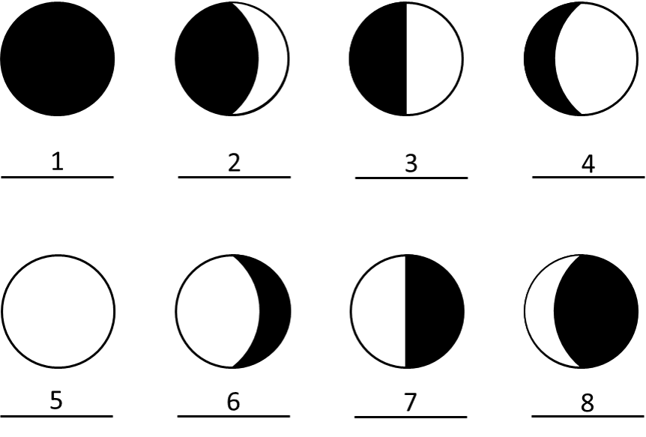
- Identify the phase of the Moon for each case above.

Number | Moon Phase
1
2
3
4
5
6
7
8
- Using Stellarium, which side of the face of the Moon is illuminated today (the left or the right)? By about how much? From that information, what is the current phase of the Moon?

Part 2: Lunar Features

Choosing Your Lunar 100 Card Features

  - Discuss with your group members if you are more interested in observing maria or craters (or another type of feature such as terrae, mountains, rilles, or faults (these might be tough)). Spend time looking at the Lunar 100 Card to see the drawn features there and a brief description of these objects. Write the name of the surface feature class you have selected, and a brief description of why it is of interest to you here.

  - Now you will choose the exact features for observation by your team. Pick two features from the Lunar 100 Card within the same category visible on the Moon tonight. Familiarize yourself with where each feature is on the Moon, and how big it is, so you can find it easily during our observational activity. It would probably be a good idea to pick a feature in the top 50, since they will be larger and easier to see in a small telescope.

We describe the location of features on the Moon by longitude and latitude, just like here on Earth. The selenographic longitude and latitude can be read from the Lunar 100 map or from the table on the back of the Lunar 100 card. Record information about your features in the table below.

Feature Name | Feature Class | Lunar 100 # | Latitude | Longitude

Studying Information on Your Features

  - This project will be much more interesting and meaningful if you know something about the surface feature you are observing. Do a bit of internet research on each of your features, and note anything that you learn below.

  - Once you are up on the roof, estimate the azimuth, altitude, and angular size of the Moon and record this information below. Reference the diagram and definitions that are also provided.

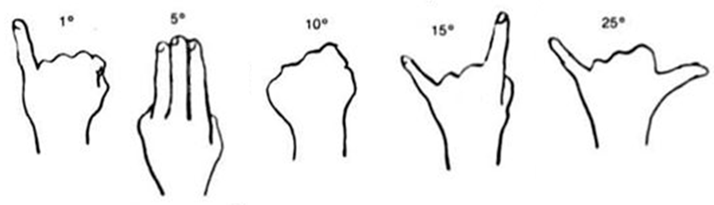
Azimuth – angle around the horizon, starting from the North and increasing to the East. Ranges from 0° to 360°. (Use a resource such as Google Maps to locate North, East where you are.)
Altitude – angle above the horizon. Ranges from 0° at the horizon to 90° at the zenith.

  - Given that the sky rotates 15o per hour towards the west, estimate the rise, set, and meridian transit times of the Moon. Explain how you arrived at your answers.

Telescope Use and Characteristics

The main controls you will use are the focusing knob to allow you to get the clearest image for your eyes, and the Right Ascension Slow Motion. This is a knob that moves the telescope on a diurnal circle and compensates for the rotation of the Earth.

  - In the space below, describe the telescope you are using including the telescope type, and primary aperture size, and the focal length of the eyepiece you are using. The shorter the focal length of the eyepiece, the higher the magnification.

Observations of the Moon with a Telescope

Now find each of the two features you chose for observations.
Consult with your team members and your teaching assistant to be sure you find it. Pay particularly close attention to the fact that the image in the eyepiece will be inverted with respect to what you see in the sky with your eye. Left will be flipped to right, and up may be flipped to down.

  - Make a sketch of the entire Moon through your telescope, showing a circle representing the Moon, shading the dark part as seen through your telescope, and making an X indicating the location of your two features. Label which is which.

Make a careful drawing of each feature in the spaces below. Use another piece of paper or the back of this document if you need more space.

  - Lunar Surface Feature 1 Drawing:

  - Lunar Surface Feature 2 Drawing:

Description of Chosen Features

  - In the space below, summarize what you learned about these features from reading online. Describe your observations of each of your lunar features verbally. Discuss how your observations illustrate some aspect of what you learned about your features from reading and researching online. Your discussion of each feature should be about a paragraph in length.

(Backup in Case of Cloudy Skies or for Online Labs:
Lunar Observations with Lunar Reconnaissance Orbiter Spacecraft)
You will find your 2 surface features on the maps of the Lunar Reconnaissance Orbiter (LRO). The URL is https://lunar.gsfc.nasa.gov/ First of all, note the lunar (selenographic) latitude and longitude of each of your features, and use the Lunar 100 map to identify the part of the Moon where the feature is. Follow these instructions in getting to the LRO images of interest.
    - On the top menu bar on the web site, hover your cursor over “Science and Data”.
    - Click on “Data Resources”.
    - In the center column of the following page, click on the center banner "LRO/LROC Target Observation Request".
    - The next screen will be a Moon map with a lot of blue and green dots on it. These are the "LROC Master Targets" and they are not needed in the display for these purposes. Choose the format of the map in the menu window on the right, deselecting "LROC Master Targets" in the top half of the menu under "Overlays".
    - We want a latitude and longitude grid placed on the map. In the top half of the menu window under "Overlays", select "Long/Lat Grid".
    - If desired, choose what is plotted in the bottom half of the menu window under "Base Layer". The default, "LROC/WAC mosaic" is probably best choice to use, but feel free to experiment.
    - Your group can zoom in on the image and move around on the surface of the Moon with the zoom and motion tool on the left hand side of the image. Using the Lunar 100 card and the selenographic latitude and longitude of your features, find your targets and expand them to the point where you can see them in detail. Now proceed to the questions above and complete sketches and descriptions of what you see.

