Names:

Grade

Observing with the VAO

# Pre-Lab Quiz

Record your team’s answers as well as your reasonings andexplanations. 1-4.

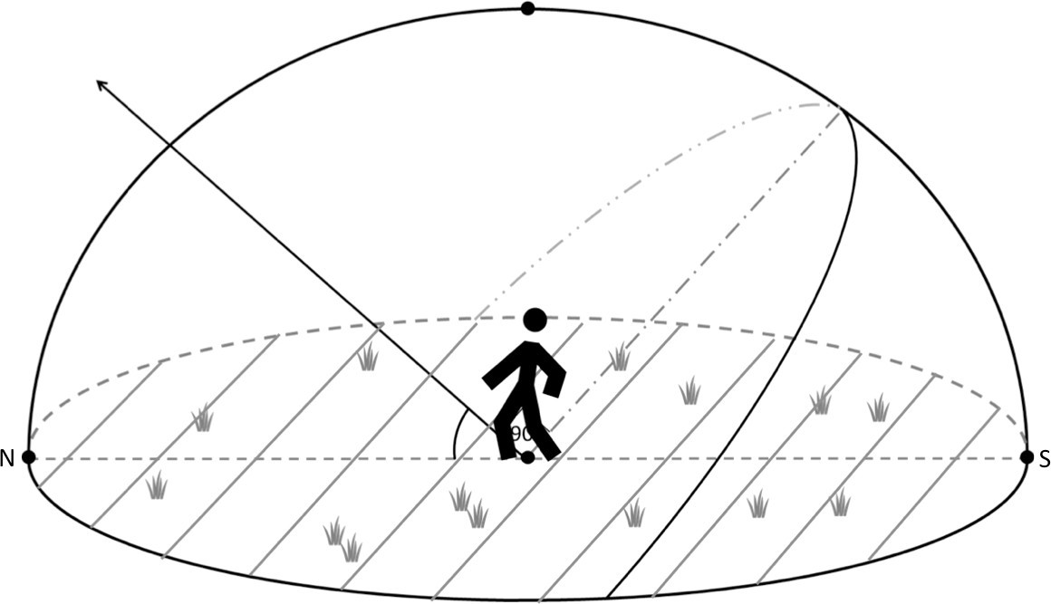

# Part 1: The VAO and Target Selection

1. What kind of telescope is the Van Allen Observatory? Is this a reflecting or refracting telescope? Roughly sketch how light goes through this telescope to be focused on the camera.
2. Research the objects on the list of candidate targets, picking one to be your final observation target. It should be visible tonight from 8-10pm and have an altitude of at least 30 degrees during that time.

What object did you select? Write a brief summary about it below, including what type of object it is and details about its appearance.

# Part 2: Selecting a VAO Filter

1. For the following filters on the VAO given on the lab webpage, report its wavelength range (the minimum and maximum wavelengths). Is this filter a broadband or narrowband filter? Also approximate the central wavelength of the filter. What color of light does this filter correspond to in the electromagnetic spectrum?

|  |  |  |  |  |
| --- | --- | --- | --- | --- |
| Filter Name | Wavelength Range  (nm) | Filter Type | Central Wavelength  (nm) | Color |
| R |  |  |  |  |
| G |  |  |  |  |
| B |  |  |  |  |
| H-alpha |  |  |  |  |

1. Why does the VAO have filters?
2. Choose a filter to observe your final observation target in and list it below. Why is this filter a good choice for observing your target?

# Part 3: CCDs and Selecting an Exposure Time

1. What is the pixel size of the CCD camera on the VAO? Compare this value to the widths of human hairs, whose diameters fall in the range of 20-200 microns (μm).
2. For an observatory, what does field of view (FOV) mean? What is the field of view of the Van Allen Observatory?
3. Select an appropriate exposure time for your final observation target and fill out the table below. Justify why that time is appropriate for the object and filter you selected.

|  |  |  |  |  |
| --- | --- | --- | --- | --- |
| Final  Observation Target | RA | Dec | Filter Choice | Exposure  Time Selection(s) |
|  |  |  |  |  |