Names:

Grade

Solar Observations

# Pre-Lab Quiz:

Record your answers as well as your reasonings and explanations.

|  |
| --- |
| 1. |
| 2. |
| 3. |
| 4. |

# Part 1: Features of the Sun

1. Pick two types of images of the Sun to study from the following options and record your selection in the chart below:

* + white light images (BBSO)
  + magnetic field pattern images (SDO, sometimes available through BBSO)
  + ultraviolet light images (SoHO, SDO)
  + coronagraph images (SoHO)

**Please note:** If you chose to study ultraviolet light images, you must select a specific wavelength in Angstroms and write this below (for example, SoHo’s ‘EIT 195’ (A) or SDO’s ‘AIA 211 A’).

|  |  |
| --- | --- |
| Image #1 | Image #2 |
|  |  |

1. Describe the disk of the Sun as it appears in the first type of image your group chose, noting anything that strikes you as noteworthy or interesting. You should note which Solar features you think you can see, and also specifically state what phenomena were not present in your images and why you think this is. Also note the day and time the image was taken. (The BBSO, SoHO, and SDO usually display images in real time/near-real time, but this is not always the case, so this is important information to note. Furthermore, note that if you came back to observe the Sun again tomorrow, or next week, these images would all look different.)
2. Draw the Sun as it appears in the first type of image you chose on the diagram below. Label features and record their locations as accurately as you can.

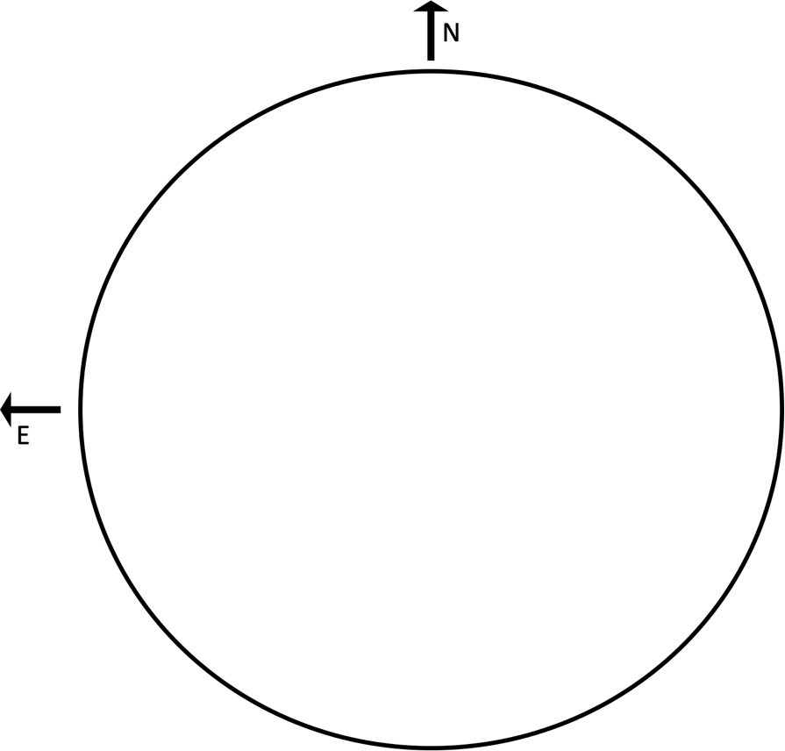

1. Describe the disk of the Sun as it appears in the second type of image your group chose, noting anything that strikes you as noteworthy or interesting. You should note which Solar features you think you can see, and also specifically state what phenomena where not present in your images and why you think this is. Also note the day and time the image was taken.
2. Draw the Sun as it appears in the second type of image you chose on the diagram below. Label features and record their locations as accurately as you can.



1. Compare and contrast what you saw when looking at the two types of images.

# Part 2: Observing the Sun

1. Draw the Sun as it appears in Hα light on the diagram below, as viewed through one of the solar telescopes on the roof. Label features and record their locations as accurately as you can. Also note the day and time of your observation or the day and time the image was taken.



1. Compare and contrast what you saw when looking at the Sun in Hα light with what you saw in your images in Questions 3 and 5 of Part 1.