Names:

Grade

Mass of Jupiter

Pre-Lab Quiz
Record your team’s answers as well as your reasonings and explanations.

1.
2.
3.
4.

Part 1: Identifying the Galilean Moons
Using the MACRO Professor Robert L. Mutel Telescope (RLMT), Jupiter has been imaged five times over two days (note the timestamps in the lower right of the images in the figure below).

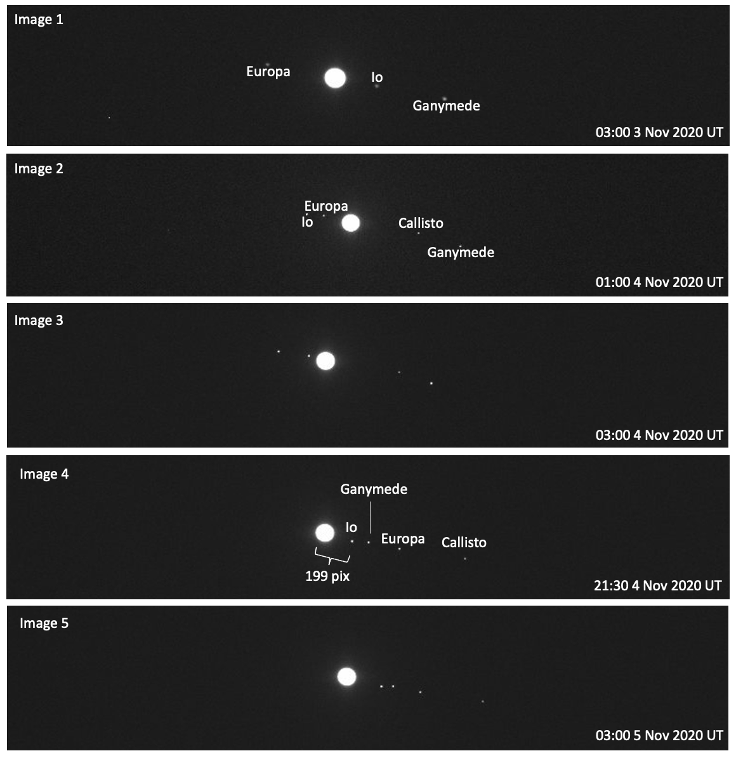
- In the images provided, as time passes, why do the Galilean moons appear to move along a line from upper left of the images to bottom right of the images? (Why don’t the
moons orbit around Jupiter in a circle (ellipse) as if you're viewing everything from above?)

- Using the Find Jupiter's Moons App linked on the lab webpage for this part of the lab, identify each of the four Galilean moons shown in Images 3 and 5. For
each image, you can either label the moons on the figure on the previous page or list the names of the moons below in order of appearance from left to right.

- In Image 1, why do you think the fourth Galilean moon, Callisto, is not labeled or pictured?

- Between the times Image 1 and Image 4 were taken, Jupiter’s moon Io completed exactly one full orbit around Jupiter. What is P, the orbital period of Io, the time it takes to go around Jupiter once, in hours, days, and Earth years?

P (hr)
P (days)
P (yr)

- As Io was imaged as it orbited Jupiter, the imaging time of Image 4 was noteworthy. This is because at this time, Io was at the furthest right of Jupiter of any other time in its orbit. Because of this, Image 4 can be used to identify a, Io’s semi-major axis, or Io’s average distance from Jupiter. We will use θ for a in arcseconds to be consistent with the version of the Small Angle Formula we’ve worked with before. In Image 4 above, θ is given in pixels. Noting that the pixel scale of the RLMT is 0.54”/pix, what is θ in arcseconds?

- In the above images, Jupiter is approximately 66 pixels in diameter. Using the the pixel scale listed above in Question 5, find the angular size of Jupiter in arcseconds.

Part 2: Applying Kepler’s Law
  - Use the Find Jupiter's Moons App linked on the lab webpage for this part of the lab to find the value of d, the distance from Earth to Jupiter at the time of your images in AU at the time these images were taken. Record d below.

  - Using the Small Angle Formula below, d in AU from Question 1, and θ in arcseconds from Question 5 in Part 1, determine Io’s semi- major axis D in AU, rearranging the Small Angle Formula as needed.

$${}_{arcseconds}=206265×\frac{D_{AU}}{d}$$

  - Using semimajor axis D in AU from Question 2, P in Earth years from Question 4 in the previous part of this lab, and the version of Kepler’s Third Law below, determine the mass of Jupiter M in solar masses, M_{Sun}.
Note: In order for this version of Kepler’s Third Law to apply, where M is returned in
M_{Sun}, D must be in AU and P must be in Earth years.

$$M=\frac{D^{3}}{P^{2}}$$

  - What is the mass of Jupiter M, not relative to the Sun in solar masses, M_{Sun}, as before, but relative to the Earth in Earth masses, M_{Earth}?
Note: 332,900 M_{Earth} = 1 M_{Sun}.

5. Using Wolfram Alpha, look up Jupiter’s mass (measured in Earth masses). Compare the known value to your calculated value from Question 4 above using the Percent Error Formula.

Part 3: The Juno Spacecraft

- Juno is a NASA spacecraft that launched in 2011 to study the planet Jupiter’s composition, gravitational field, and magnetosphere. You will be using MaxIm DL to create a tri-color image from data collected by JunoCam, an instrument onboard this spacecraft. To find the image files, navigate to the following folder:

This PC → Astronomy_Lab_images → Planet → Jupiter→ JunoCam

TA Stamp

Once you have created your color-balanced image, share it with your TA to receive a stamp.

- Using the Small Angle Formula below, the distance d from Part 2, Question 1, and θ in arcseconds from Part 1, Question 6, determine Jupiter’s diameter D in AU, as you did in Question 2 from Part 2. Express your answer in scientific notation.

$${}_{arcseconds}=206265×\frac{D_{AU}}{d}$$

- Knowing that the FOV of JunoCam is 58°, estimate the angular diameter, , of Jupiter.

- Using the angular diameter from the previous question and the physical diameter D from Question 2, solve for the distance d from the Juno spacecraft to Jupiter in AU.

Note: You should use the tangent relationship to solve (not the Small Angle Formula).

- Assume that this distance is Juno’s semi-major axis. Using Kepler’s third law, listed below, find the orbital period of Juno in years.

$$M=\frac{D^{3}}{P^{2}}$$

- Convert the orbital period you found above from years to hours.

