Names:

Grade

Mass of Jupiter

Pre-Lab Quiz
Record your team’s answers as well as your reasonings and explanations.

1.
2.
3.
4.

Part 1: Identifying the Galilean Moons
Using the MACRO Professor Robert L. Mutel Telescope (RLMT), Jupiter has been imaged five times over two days (note the timestamps in the lower right of the images in the figure below).

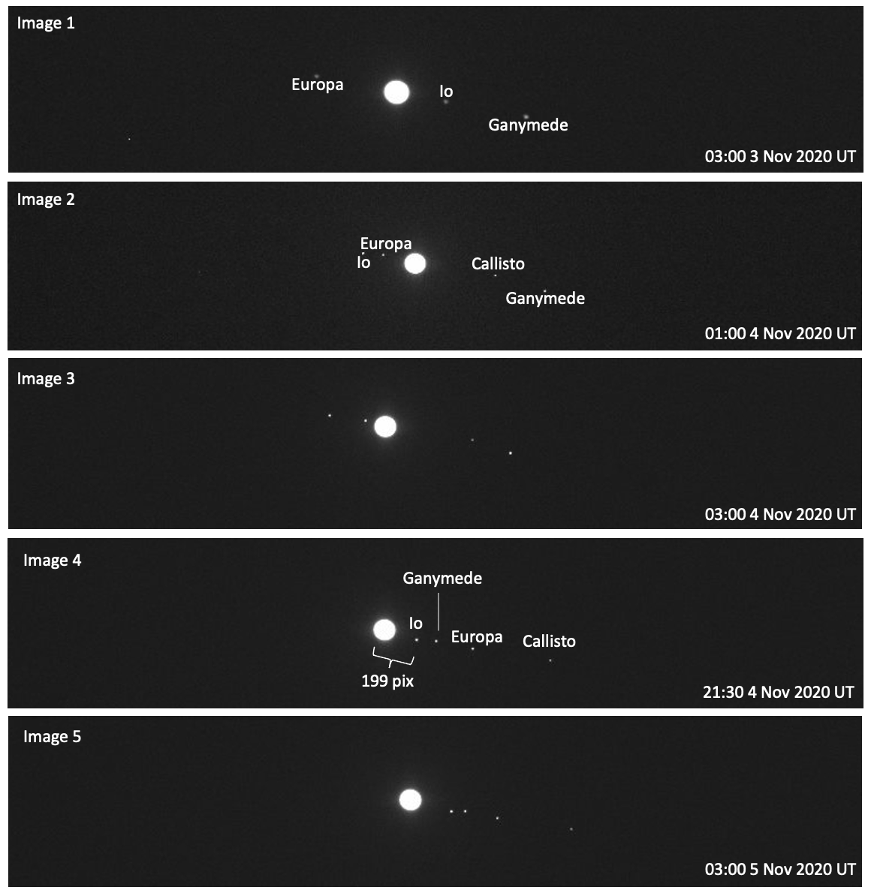
- As time passes between the images, why do the Galilean moons appear to move along a line from upper left of the images to bottom right of the images? Why don’t the moons appear to orbit around Jupiter in a circle or ellipse?

- Using the Find Jupiter's Moons App linked on the lab webpage for this part of the lab, identify each of the four Galilean moons shown in Images 3 and 5. For each image, list the names of the moons below in order of appearance from left to right.

- In Image 1, why do you think the fourth Galilean moon, Callisto, is not labeled or pictured?

- Between the times Image 1 and Image 4 were taken, Jupiter’s moon Io completed exactly one full orbit around Jupiter. Record P, the orbital period of Io, in hours, then convert this to days and years.

P (hr)
P (days)
P (yr)

- In Image 4, Io was at the furthest right of Jupiter of any other time in its orbit. Because of this, Image 4 can be used to identify a, Io’s semi-major axis, or Io’s average distance from Jupiter. The distance between Jupiter and Io is measured to be 199 pixels. Knowing that the pixel scale of the RLMT is 0.54”/pix, convert from pixels to arcseconds to find the angular size θ .

- In the above images, Jupiter is approximately 66 pixels in diameter. Using the the pixel scale listed above in Question 5, convert from pixels to arcseconds to find the angular size of Jupiter.

Part 2: Applying Kepler’s Law
  - Use the Find Jupiter's Moons App linked on the lab webpage for this part of the lab to find the value of d, the distance from Earth to Jupiter (in AU) at the time that the 5th image was taken. Record d below.

  - Using the Small Angle Formula below, the distance d in AU from the previous question, and θ in arcseconds from Question 5 in Part 1, determine Io’s semi- major axis D in AU, rearranging the Small Angle Formula as needed.

$${}_{arcseconds}=206265×\frac{D_{AU}}{d}$$

  - Using semimajor axis D in AU from Question 2, P in Earth years from Question 4 in Part 1, and the version of Kepler’s Third Law below, determine the mass of Jupiter M in solar masses, M_{Sun}, rearranging Kepler’s Third Law as needed.
Note: In order for this version of Kepler’s Third Law to apply, where M is returned in
M_{Sun}, D must be in AU and P must be in Earth years.

$$P^{2}=\frac{D^{3}}{M}$$

  - Now that you have found the mass of Jupiter in solar masses, M_{Sun}, determine the mass of Jupiter relative to the Earth, M_{Earth}. Convert using the equation below.
Note: 332,900 M_{Earth} = 1 M_{Sun}.

5. Using Wolfram Alpha, look up Jupiter’s mass (measured in Earth masses). Compare the known value to your calculated value from Question 4 above using the Percent Error Formula.

Part 3: The Juno Spacecraft

- Juno is a NASA spacecraft that launched in 2011 to study the planet Jupiter’s composition, gravitational field, and magnetosphere. You will be using MaxIm DL to create a tri-color image from data collected by JunoCam, an instrument onboard this spacecraft. To find the image files, navigate to the following folder, and open all three images:

This PC → Astronomy_Lab_images → Planet → Jupiter→ JunoCam→ blue.fits, green.fits, red.fits

TA Stamp

Once you have created your color-balanced image, share it with your TA to receive a stamp.

- Using the Small Angle Formula below, the distance d from Part 2, Question 1, and θ in arcseconds from Part 1, Question 6, determine Jupiter’s diameter D in AU, as you did in Question 2 from Part 2. Express your answer in scientific notation.

$${}_{arcseconds}=206265×\frac{D_{AU}}{d}$$

- Knowing that the FOV of JunoCam is 58°, estimate the angular diameter, , of Jupiter.

- Using the angular diameter from the previous question and the physical diameter D from Question 2, solve for the distance d from the Juno spacecraft to Jupiter in AU.

Note: You should use the tangent relationship to solve (not the Small Angle Formula).

- Assume that this distance d is Juno’s semi-major axis. Using the version of Kepler’s Third Law below, the semimajor axis d in AU from the previous question, and Jupiter’s mass in solar masses M_{Sun} from Question 3 in Part 2, find the orbital period P of Juno in Earth years.

$$P^{2}=\frac{d^{3}}{M}$$

- Convert the orbital period P of Juno from Earth years to hours.

