Name: _________________ Clear Skies Date: ____________________

|  |  |  |  |  |
| --- | --- | --- | --- | --- |
|  |  |  | Grade |  |

**Part 1: Observing**

1. Have the TA mark below.

|  |  |  |  |  |
| --- | --- | --- | --- | --- |
|  |  |  | TA |  |

1. What types of telescopes were used for the Clear Skies observation (reflecting or refracting)? What was the aperture size (the size of the primary mirror or lens)? Include the appropriate units (inches, meters, etc.)

| Telescope Name | Telescope Type | Aperture Size |
| --- | --- | --- |
| VAO (dome) |  |  |
| silver Celestron telescopes |  |  |
| white Orion telescopes |  |  |

1. Using the hand signals you learned in the Measuring the Sky lab, estimate the altitude and azimuth of the following objects:

**Altitude** – angle between the object and the horizon, ranging from 0 degrees to 90 degrees (at the zenith)

**Azimuth** – angle of the object around the horizon, starting at true north (0 degrees), and continuing clockwise to 360 degrees

**Angular size** – the amount of size an object takes up in your field of view

| Object | Altitude | Azimuth | Angular Size |
| --- | --- | --- | --- |
| Old Capitol Dome |  |  |  |
| Channel 4 Clock Tower |  |  |  |

1. Record the name of 3 objects you observed through the telescopes. Using the internet, research the distance to each object (include the appropriate units) and one additional fact.

| Object | Distance | Fact |
| --- | --- | --- |
|  |  |  |
|  |  |  |
|  |  |  |

**Part 2: At-home**

1. The concept map below details the relationships among many astronomical objects commonly imaged by optical telescopes. For each of the objects you observed, mark the appropriate location of the object and list its name.

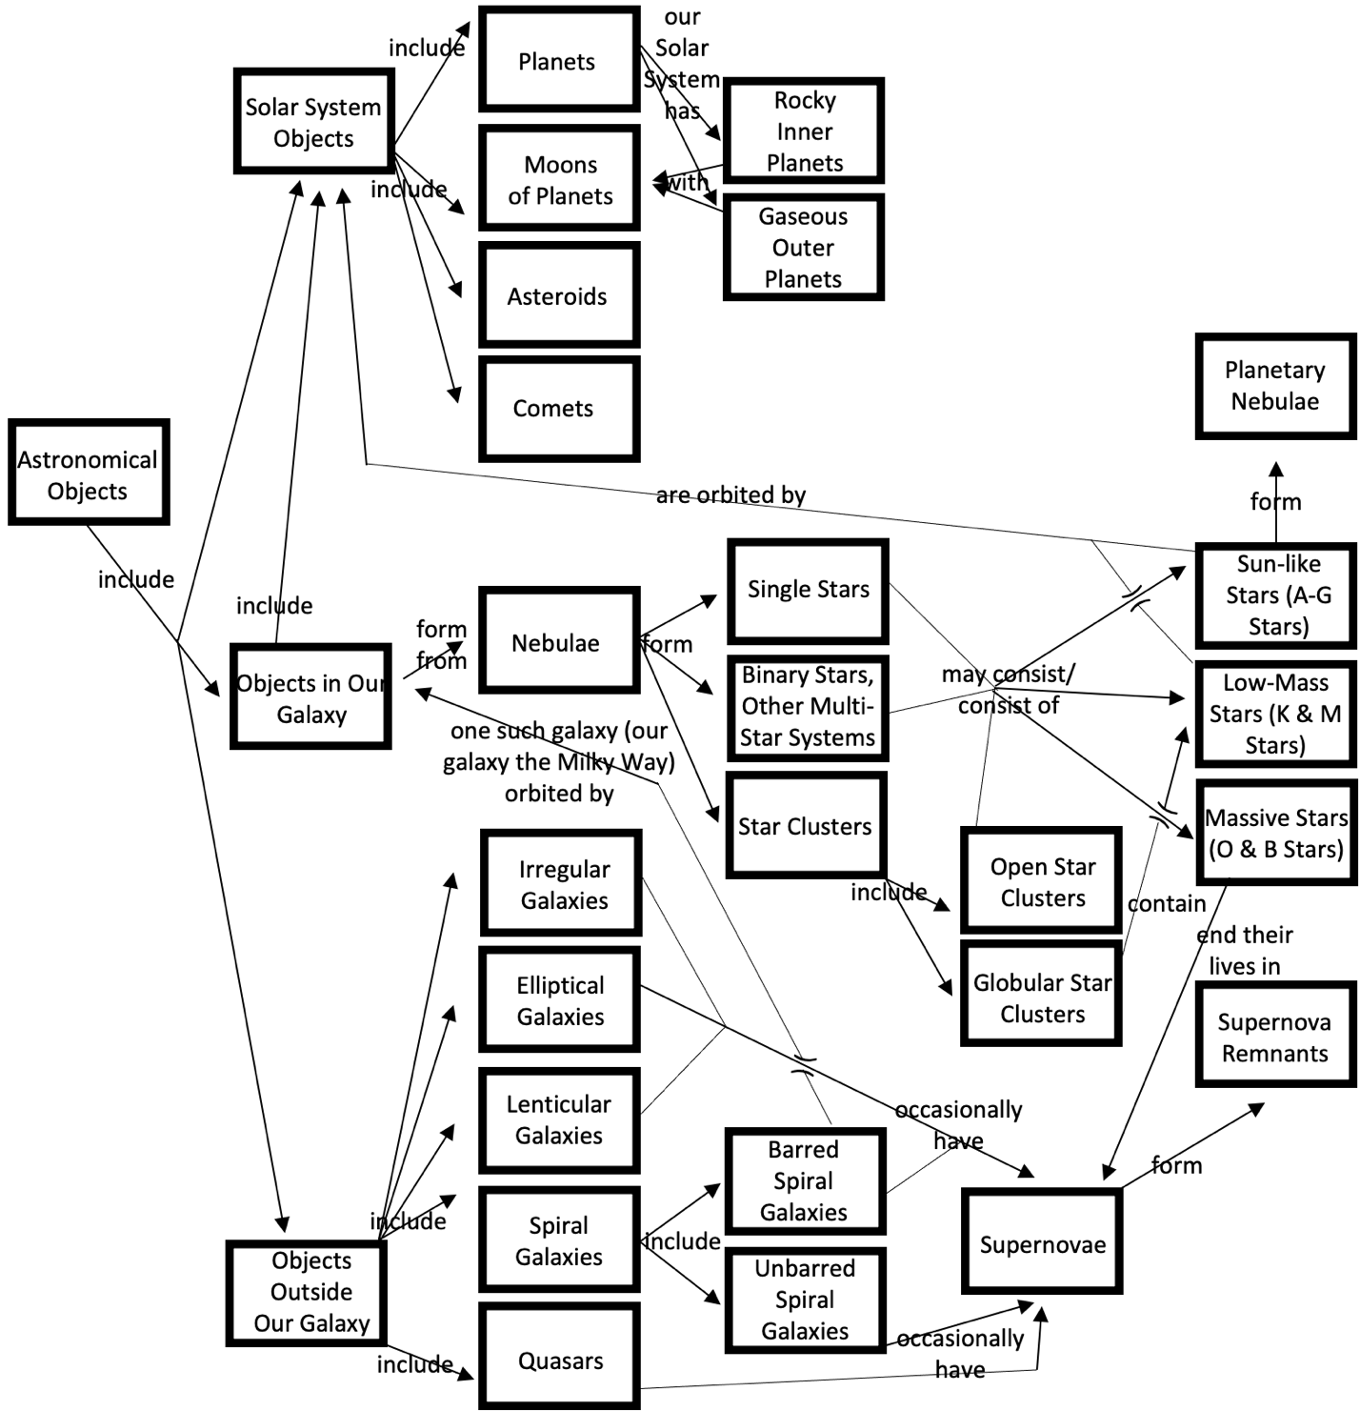

1. The magnification of a telescope can be determined using the following equation:

The silver Celestron telescopes have a focal length of 1500mm. Use this to determine the magnification of these telescopes using various eyepieces:

| Eyepiece Focal Length | Telescope Magnification |
| --- | --- |
| 40mm |  |
| 25mm |  |
| 12mm |  |

1. Now that you have found the magnification, you can easily calculate field of view for the telescope using the following equation:

$$telescope FOV=\frac{apparent field of view}{magnification}$$

If the apparent field of view for the 40mm eyepiece is 43 degrees, what is the telescope’s field of view? (include appropriate units)

1. If the Andromeda Galaxy has an angular size of approximately 3 degrees across, will it fit entirely within the telescope’s field of view? Why or why not?