Names:

Grade

Measuring and Exploring the Sky

# Pre-Lab Quiz:

Record you team’s answer as well as your reasonings and explanations.

|  |
| --- |
| 1. |
| 2. |
| 3. |
| 4. |

# Part 1: The Celestial Sphere

1. On the figure below, label the Earth’s Equator, the Celestial Equator, the Ecliptic, the North Celestial Pole (NCP), the South Celestial Pole (SCP), the Earth’s Rotational Axis, and the position of the star Polaris. On this diagram of the celestial sphere, label the Sun’s position when the Summer Solstice, Winter Solstice, Vernal Equinox, and Autumnal Equinox occur.

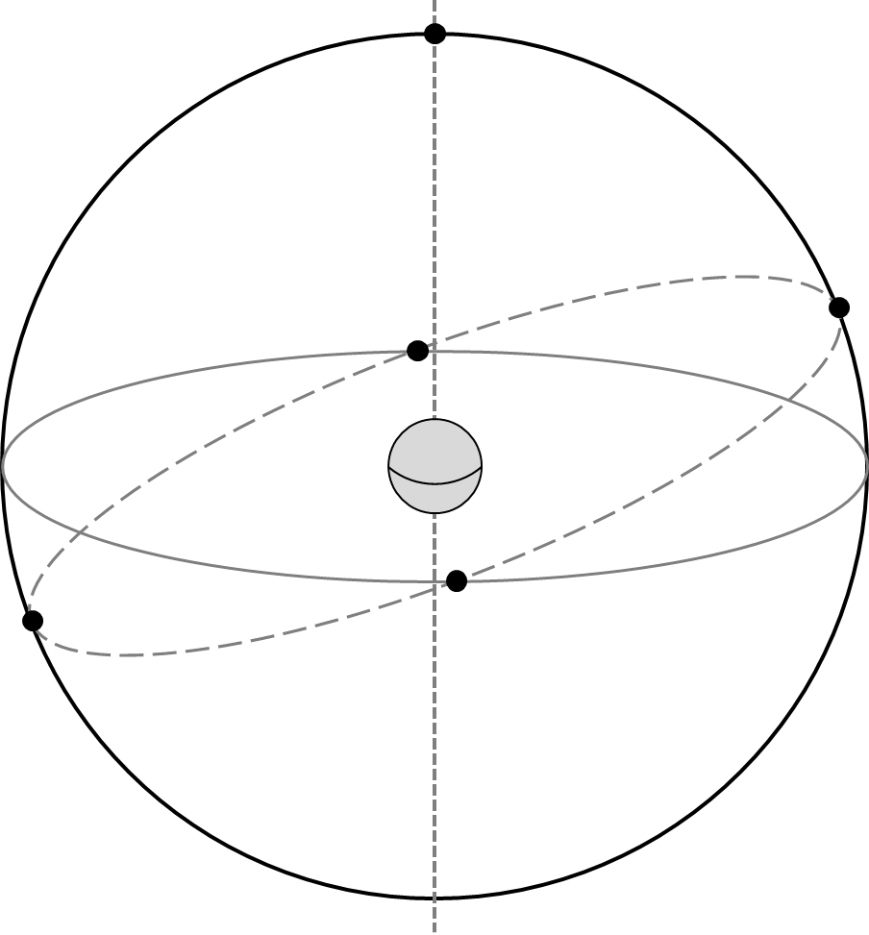

1. What angle is the ecliptic inclined with respect to the celestial equator? Include units in your answer.
2. What celestial objects lay on or near the ecliptic? Name at least five. Explain more about your answers: What is the significance of the ecliptic? Why do so many noteworthy celestial objects lie in this area of the sky?

# The Celestial Sphere: Local Viewpoint

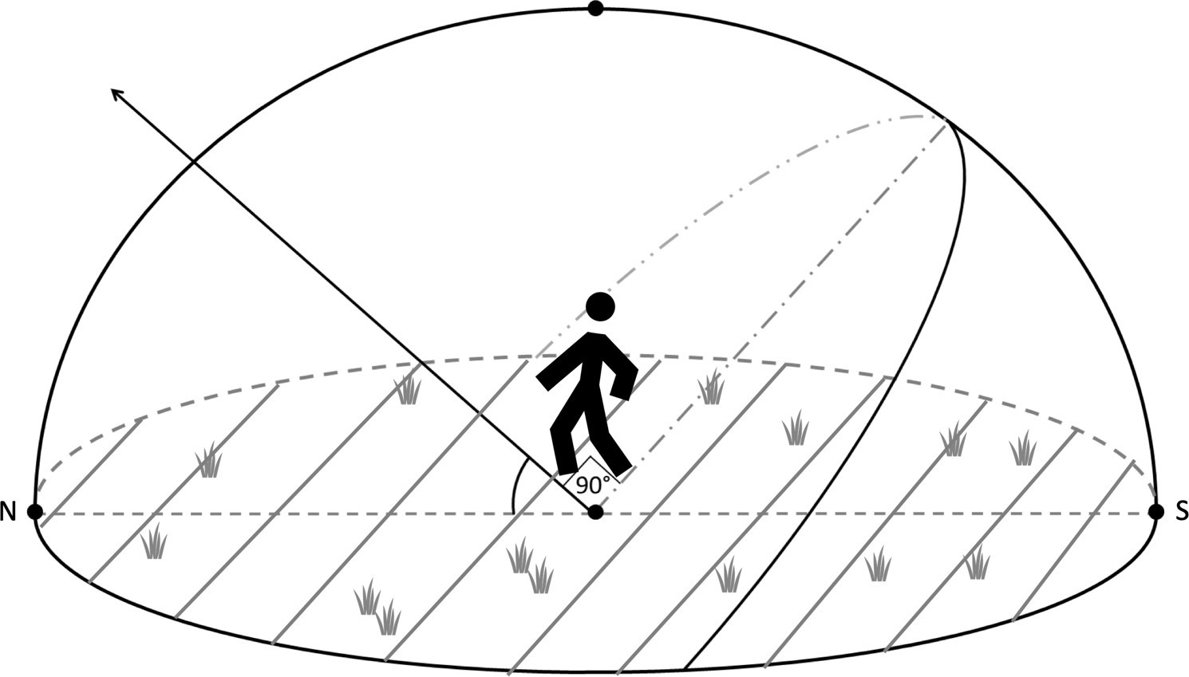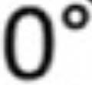

1. A person stands outside beneath the dome of the night sky. Assume the diagram below is for Iowa City, which is at a latitude of ~42 degrees. Identify and label the following: the Celestial Equator, the North Celestial Pole, Zenith, the Meridian, the Horizon, and the cardinal directions South, East, and West along with their Azimuth Angle. Then draw where Polaris is and draw the path of a star over the course of one night.
2. For Iowa City, what is the Sun’s elevation at noon on the Vernal Equinox? Mark it on the diagram above and include units in your answer.

**Hint**: Where is the general position of the Sun at noon (on the horizon, below the horizon, high in the sky, etc.)? Next, see the first figure from this lab in Question 1. You labeled the Sun’s exact position when the Vernal Equinox occurs. On that date, where the Sun is in relation to the Celestial Equator? Remembering the latitude of Iowa City, what is the height of the highest point of the celestial equator in Iowa City?

1. For Iowa City, what is the elevation of the Sun at noon on the Summer Solstice? Mark it on the diagram above and include units in your answer.

# Part 2: Using a Star Wheel

1. Dial up 9 pm on your star wheel by aligning today’s date with 9 pm. Find a constellation that has just risen. Find a constellation that has just set.

**Hint**: how can one simulate the passage of time throughout the night on a star wheel?

|  |  |
| --- | --- |
| Constellation – Just Risen |  |
| Constellation – Just Set |  |

1. The point about which the sky rotates in the northern hemisphere is called the *North Celestial Pole* (NCP)*.* What star is associated with the NCP and what constellation is it part of?
2. The *zenith* is defined as the point on the celestial sphere directly above an observer. On the star wheel, the zenith will be at the center of the visible portion of the sky. What constellation will be closest to the zenith at 9 pm tonight?
3. The *meridian* is a great circle on the celestial sphere that passes through the north and south celestial poles and an observer’s zenith. List some constellations that will be along the meridian at **midnight** tonight.
4. The word *circumpolar* is used to denote objects that never set below the horizon, and thus are visible at all times of the year.
   1. Using the star wheel, list three circumpolar constellations for Iowa City.
   2. Where in the sky would one look to find them?
5. Where would one currently look to find *Ursa Major* (Big Dipper)?
6. The Summer Triangle consists of the three bright stars *Altair*, *Deneb*, and *Vega*. While it isn’t a constellation, it is one of the most famous "asterisms" (pattern of stars) in the night sky. During which months will it be visible at midnight?
7. The Orion constellation is home to the picturesque Orion Nebula, a popular target for amateur astronomers. Will Orion be visible tonight? If so, during what times? If not, when will it become visible in the early morning (4 am) again?
8. Arcturus (*Guardian of the Bear*) is the fourth brightest star in the night sky and is located in the constellation Boötes. Draw a diagram of the Big Dipper and illustrate how to find Arcturus and Polaris using the Big Dipper as your starting point. Also label Mizar-Alcor, part of the constellation Ursa Major and one of the most famous multi-star systems. More than half of all stars are thought to be part a system with two or more stars.

# Part 3: Estimating Angles

In this part we’ll practice measuring the sky. The main point of this activity will be to estimate the azimuth, altitude, and angular size of a number of objects. The figure below is a handy guide for estimating angles with your hand when held at arm’s length.

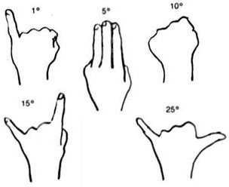

1. Determine the direction North. Determine the direction of East. Describe how you would show someone the position of the meridian through the sky.
2. Depending on the weather and your lab section, proceed to the proper section. Note the following definitions:

*Azimuth* – angle around the horizon, starting from North and increasing to the East. Ranges from 0° to 360°.

*Altitude* – angle above the horizon. Ranges from 0° at the horizon to 90° at the zenith.

## Cloudy or Day Lab: Roof

For each of the following objects, estimate their azimuth angle and their angular size. Your TA will point out any objects that you need help identifying.

|  |  |  |
| --- | --- | --- |
| Object | Azimuth Angle | Angular Size |
| The Chauncey |  |  |
| Clock Tower Clock Face to the North |  |  |
| Grey Stone Church to the Northwest |  |  |
| VAO Telescope Dome* |  |  |

*Viewed from the entrance to the roof.

## Night Lab with Clear Skies: Fall, Roof

Your TA will point out several objects in the night sky. Estimate the various quantities in the table below.

**Note:** Remember, the altitude should not exceed 90º.

|  |  |  |
| --- | --- | --- |
| Object (Type) | Azimuth Angle | Altitude Angle |
| Polaris (Star) |  |  |
| Mizar & Alcor (Double Star) |  |  |
| Vega (Star) |  |  |
| Deneb (Star) |  |  |
| Altair (Star) |  |  |

|  |  |
| --- | --- |
| Object (Type) | Angular Size |
| Big Dipper (Asterism) |  |
| Cassiopeia (Constellation) |  |
| Summer Triangle (Asterism) |  |

## Night Lab with Clear Skies: Spring and Summer, Roof

Your TA will point out several objects in the night sky. Record their names where needed and estimate the various quantities in the table below.

Note: Remember, the altitude should not exceed 90º.

|  |  |  |
| --- | --- | --- |
| Object (Type) | Azimuth Angle | Altitude Angle |
| Polaris (Star) |  |  |
| Mizar & Alcor (Double Star) |  |  |
| Rigel (Star) |  |  |
|  |  |  |
|  |  |  |

|  |  |
| --- | --- |
| Object (Type) | Angular Size |
| Big Dipper (Asterism) |  |
| Orion’s Belt (Asterism) |  |
|  |  |

## Rainy or Cold Weather Lab: VAN 666

For each of the following objects, estimate their azimuth angle and their angular size. Your TA will point out any objects that you need help identifying.

|  |  |  |
| --- | --- | --- |
| Object | Azimuth Angle | Angular Size |
| The Chauncey |  |  |
| Tower Place Parking Ramp Clock Tower |  |  |
| VAN Lecture Halls Roof |  |  |
| Lab Room Door from Your Lab Table |  |  |

## Rainy or Cold Weather Lab: VAN 665

For each of the following objects, estimate their azimuth angle and their angular size. Your TA will point out any objects that you need help identifying.

|  |  |  |
| --- | --- | --- |
| Object | Azimuth Angle | Angular Size |
| Linn Street Crosswalk |  |  |
| Clock Tower Clock Face to the North |  |  |
| Grey Stone Church to the Northwest |  |  |
| Lab Room Door from Your Lab Table |  |  |