Names:

Grade

Measuring the Sky

# Pre-Lab Quiz:

Record you team’s answer as well as your reasonings and explanations.

|  |
| --- |
| 1. |
| 2. |
| 3. |
| 4. |

# Part 1: The Celestial Sphere

1. On the figure below, label the Earth’s Equator, the Celestial Equator, the Ecliptic, the North Celestial Pole (NCP), the South Celestial Pole (SCP), the Earth’s Rotational Axis, and the position of the star Polaris. On this diagram of the celestial sphere, label the Sun’s position when the Summer Solstice, Winter Solstice, Vernal Equinox, and Autumnal Equinox occur.

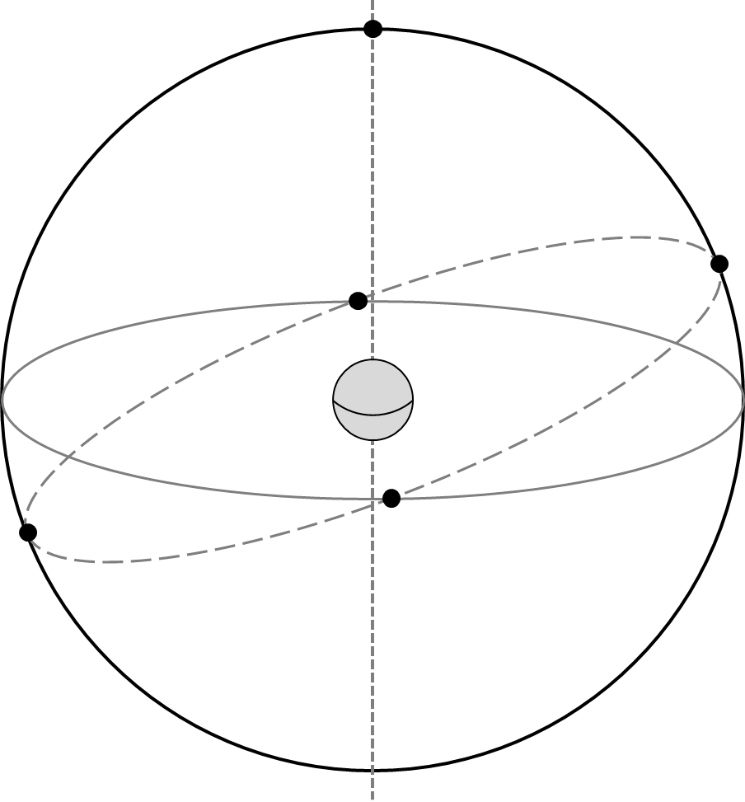

1. What angle is the ecliptic inclined with respect to the celestial equator? Include units in your answer.
2. What celestial objects lay on or near the ecliptic? Name at least five. Explain more about your answers: What is the significance of the ecliptic? Why do so many noteworthy celestial objects lie in this area of the sky?

# The Celestial Sphere: Local Viewpoint

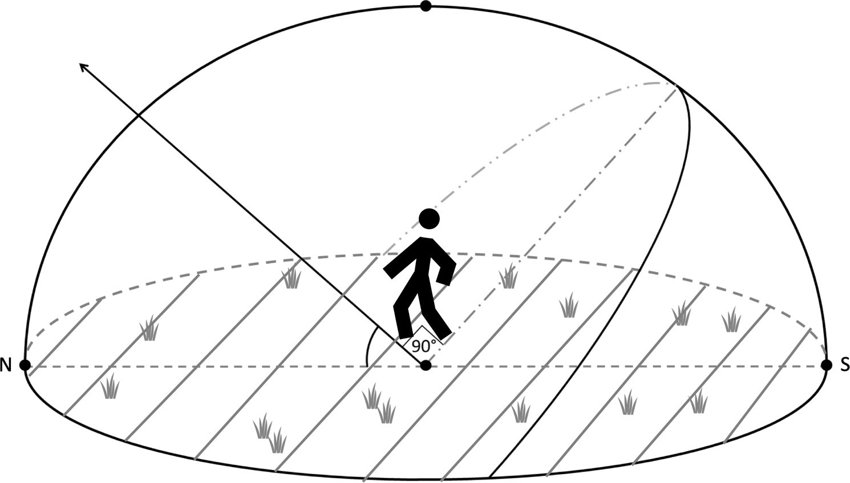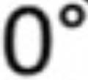

1. A person stands outside beneath the dome of the night sky. Assume the diagram below is for Iowa City, which is at a latitude of ~42 degrees. Identify and label the following: the Celestial Equator, the North Celestial Pole, Zenith, the Meridian, the Horizon, and the cardinal directions South, East, and West along with their Azimuth Angle. Then draw where Polaris is and draw the path of a star over the course of one night.
2. For Iowa City, what is the Sun’s elevation at noon on the Vernal Equinox? Mark it on the diagram above and include units in your answer.

**Hint**: Where is the general position of the Sun at noon (on the horizon, below the horizon, high in the sky, etc.)? Next, see the first figure from this lab in Question 1. You labeled the Sun’s exact position when the Vernal Equinox occurs. On that date, where the Sun is in relation to the Celestial Equator? Remembering the latitude of Iowa City, what is the height of the highest point of the celestial equator in Iowa City?

1. For Iowa City, what is the elevation of the Sun at noon on the Summer Solstice? Mark it on the diagram above and include units in your answer.

# Part 2: Estimating Angles

In this part we’ll practice measuring the sky. The main point of this activity will be to estimate the azimuth, altitude, and angular size of a number of objects. The figure below is a handy guide for estimating angles with your hand when held at arm’s length.

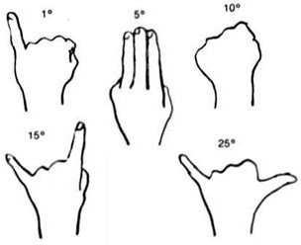

1. Determine the direction North. Determine the direction of East. Describe how you would show someone the position of the meridian through the sky.
2. Depending on the weather and your lab section, proceed to the proper section. Note the following definitions:

*Azimuth* – angle around the horizon, starting from North and increasing to the East. Ranges from 0° to 360°.

*Altitude* – angle above the horizon. Ranges from 0° at the horizon to 90° at the zenith.

## Cloudy or Day Lab: Roof

For each of the following objects, estimate their azimuth angle and their angular size. Your TA will point out any objects that you need help identifying.

|  |  |  |
| --- | --- | --- |
| Object | Azimuth Angle | Angular Size |
| Hotel Vetro |  |  |
| Clock Tower Clock Face to the North |  |  |
| Grey Stone Church to the Northwest |  |  |
| VAO Telescope Dome* |  |  |

*Viewed from the entrance to the roof.

## Night Lab with Clear Skies: Fall, Roof

Your TA will point out several objects in the night sky. Estimate the various quantities in the table below.

**Note:** Remember, the altitude should not exceed 90º.

|  |  |  |
| --- | --- | --- |
| Object (Type) | Azimuth Angle | Altitude Angle |
| Polaris (Star) |  |  |
| Mizar & Alcor (Double Star) |  |  |
| Vega (Star) |  |  |
| Deneb (Star) |  |  |
| Altair (Star) |  |  |

|  |  |
| --- | --- |
| Object (Type) | Angular Size |
| Big Dipper (Asterism) |  |
| Cassiopeia (Constellation) |  |
| Summer Triangle (Asterism) |  |

## Night Lab with Clear Skies: Spring and Summer, Roof

Your TA will point out several objects in the night sky. Record their names where needed and estimate the various quantities in the table below.

Note: Remember, the altitude should not exceed 90º.

|  |  |  |
| --- | --- | --- |
| Object (Type) | Azimuth Angle | Altitude Angle |
| Polaris (Star) |  |  |
| Mizar & Alcor (Double Star) |  |  |
| Rigel (Star) |  |  |
|  |  |  |
|  |  |  |

|  |  |
| --- | --- |
| Object (Type) | Angular Size |
| Big Dipper (Asterism) |  |
| Orion’s Belt (Asterism) |  |
|  |  |

## Rainy or Cold Weather Lab: VAN 666

For each of the following objects, estimate their azimuth angle and their angular size. Your TA will point out any objects that you need help identifying.

|  |  |  |
| --- | --- | --- |
| Object | Azimuth Angle | Angular Size |
| Hotel Vetro |  |  |
| Tower Place Parking Ramp Clock Tower |  |  |
| VAN Lecture Halls Roof |  |  |
| Lab Room Door from Your Lab Table |  |  |

## Rainy or Cold Weather Lab: VAN 665

For each of the following objects, estimate their azimuth angle and their angular size. Your TA will point out any objects that you need help identifying.

|  |  |  |
| --- | --- | --- |
| Object | Azimuth Angle | Angular Size |
| Linn Street Crosswalk |  |  |
| Clock Tower Clock Face to the North |  |  |
| Grey Stone Church to the Northwest |  |  |
| Lab Room Door from Your Lab Table |  |  |