Name:

Grade

Lunar Observations

# Pre-Lab Quiz:

Record your answers as well as your reasonings and explanations.

|  |
| --- |
| 1. |
| 2. |
| 3. |
| 4. |

# Part 1: Lunar Phases

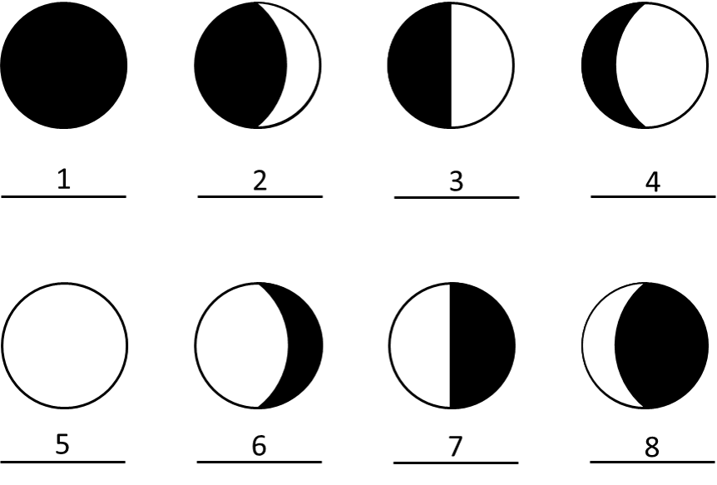

1. Identify the phase of the Moon for each case above.

|  |  |
| --- | --- |
| Number | Moon Phase |
| 1 |  |
| 2 |  |
| 3 |  |
| 4 |  |
| 5 |  |
| 6 |  |
| 7 |  |
| 8 |  |

1. Using Stellarium, which side of the face of the Moon is illuminated today (the left or the right)? By about how much? From that information, what is the current phase of the Moon?

# Part 2: Lunar Features

## Choosing Your Lunar 100 Card Features

* 1. Discuss with your group members if you are more interested in observing maria (singular: mare), craters, or both. Spend time looking at the Lunar 100 Card to see the drawn features there and a brief description of these objects. Write the name of the surface feature class you have selected (maria, craters, or both), a brief description of your class choice(s), and why it is/they are of interest to you here.
  2. Now you will choose the exact features for observation by your team. Pick two features from the Lunar 100 Card **visible on the Moon tonight** (use Stellarium to determine what is visible). Choose from the following: 5, 6, 8, 10, 11, 13, 14, 16, 18, 20, 21, 26, 27, 28, 31, 34, 56, 87, 90, 100. Familiarize yourself with where each feature is on the Moon and how big it is, so you can find it easily during our observational activity.

We describe the location of features on the Moon by longitude and latitude, just like here on Earth. The selenographic longitude and latitude can be read from the Lunar 100 map or from the table on the back of the Lunar 100 card. Record information about your features in the table below.

|  |  |  |  |  |
| --- | --- | --- | --- | --- |
| **Feature Name** | **Feature Class** | **Lunar 100 #** | **Latitude** | **Longitude** |
|  |  |  |  |  |
|  |  |  |  |  |

## Studying Information on Your Features

* 1. This project will be much more interesting and meaningful if you know something about the specific surface features you are observing. Do a bit of internet research on both of your features and note what you learn below. (For example, their formation, age, discovery, notable facts, etc.)
  2. Once you are up on the roof, estimate the azimuth, altitude, and angular size of the Moon and record this information below. Reference the diagram and definitions that are also provided.

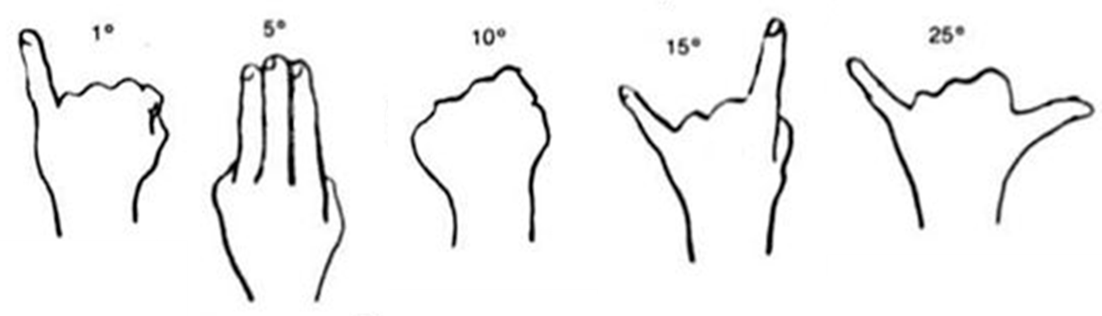

*Azimuth* – angle around the horizon, starting from the North and increasing to the East. Ranges from 0° to 360°. (Use a resource such as Google Maps to locate North, East where you are.)

*Altitude* – angle above the horizon. Ranges from 0° at the horizon to 90° at the zenith.

* 1. Given that the sky rotates 15o per hour towards the west, how many degrees has the Moon traveled since it rose? How many degrees does it need to travel before it sets? Estimate the rise, set, and meridian transit times of the Moon.

## Telescope Use and Characteristics

The main controls you will use are the *focusing knob* to allow you to get the clearest image for your eyes, and either the hand paddle or the *Right Ascension Slow Motion.* This is a knob that moves the telescope on a *diurnal circle* and compensates for the rotation of the Earth. Your TA will demonstrate.

* 1. In the space below, describe the telescope you are using including the telescope type, the primary aperture size, and the focal length of the eyepieces you will be using. The shorter the focal length of the eyepiece, the higher the magnification.

## Observations of the Moon with a Telescope

Observe the Moon with the weakest magnification eyepiece. **Pay particularly close attention to the fact that the image in the eyepiece will be inverted with respect to what you see in the sky with your eye.** Left will be flipped to right, and up may be flipped to down.

* 1. Make a sketch of the entire Moon through your telescope, showing a circle representing the Moon, shading the dark part as seen through your telescope, and making an **X** indicating the rough location of your two features. Label which is which.

Now find each of the two features you chose for observations with the stronger magnification eyepiece(s). Consult with your team members and your teaching assistant as needed. Make a careful drawing of each feature in the spaces below. Use another piece of paper if you need more space.

* 1. Lunar Surface Feature 1 Drawing:

* 1. Lunar Surface Feature 2 Drawing:



## Description of Chosen Features

* 1. In the space below, describe your observations of each of your lunar features. Mention how your observations illustrate some aspect of what you learned about your features from reading and researching online for Question 3.

## (Backup in Case of Cloudy Skies or for Online Labs:

**Lunar Observations with Lunar Reconnaissance Orbiter Spacecraft)**

You will find your 2 surface features on the maps of the Lunar Reconnaissance Orbiter (LRO). The URL is science.nasa.gov/mission/lro/ First of all, note the lunar (selenographic) latitude and longitude of each of your features, and use the Lunar 100 map to identify the part of the Moon where the feature is. Follow these instructions in getting to the LRO images of interest.

* + - On the top menu bar on the web site, click on “Science & Data” and then click on "Data Products".
    - Then scroll down and click on the arrow to the right of "Target Observation Request".
    - The next screen will be a Moon map with, when you zoom in, a lot of blue and green dots on it. These are the "LROC Master Targets" and they are not needed in the display for these purposes. Choose the format of the map in the menu window on the right, deselecting "LROC Master Targets" in the top half of the menu under "Overlays".
    - We want a latitude and longitude grid placed on the map. In the top half of the menu window under "Overlays", select "Long/Lat Grid".
    - If desired, choose what is plotted in the bottom half of the menu window under "Base Layer". The default, "LROC/WAC mosaic" is probably best choice to use, but feel free to experiment.
    - Your group can zoom in on the image and move around on the surface of the Moon with the zoom and motion tool on the left hand side of the image. Using the Lunar 100 card and the selenographic latitude and longitude of your features, find your targets and expand them to the point where you can see them in detail. Now proceed to the questions above and complete sketches and descriptions of what you see.