Names:

Grade

Measuring the Sky

Pre-Lab Quiz:
Record you team’s answer as well as your reasonings and explanations.

1.
2.
3.
4.

Part 1: The Celestial Sphere & Local Viewpoint
- On the figure below, label the Earth’s Equator, the Celestial Equator, the Ecliptic, the North Celestial Pole (NCP), the South Celestial Pole (SCP), the Earth’s Rotational Axis, and the position of the star Polaris. On this diagram of the celestial sphere, label the Sun’s position when the Summer Solstice, Winter Solstice, Vernal Equinox, and Autumnal Equinox occur.

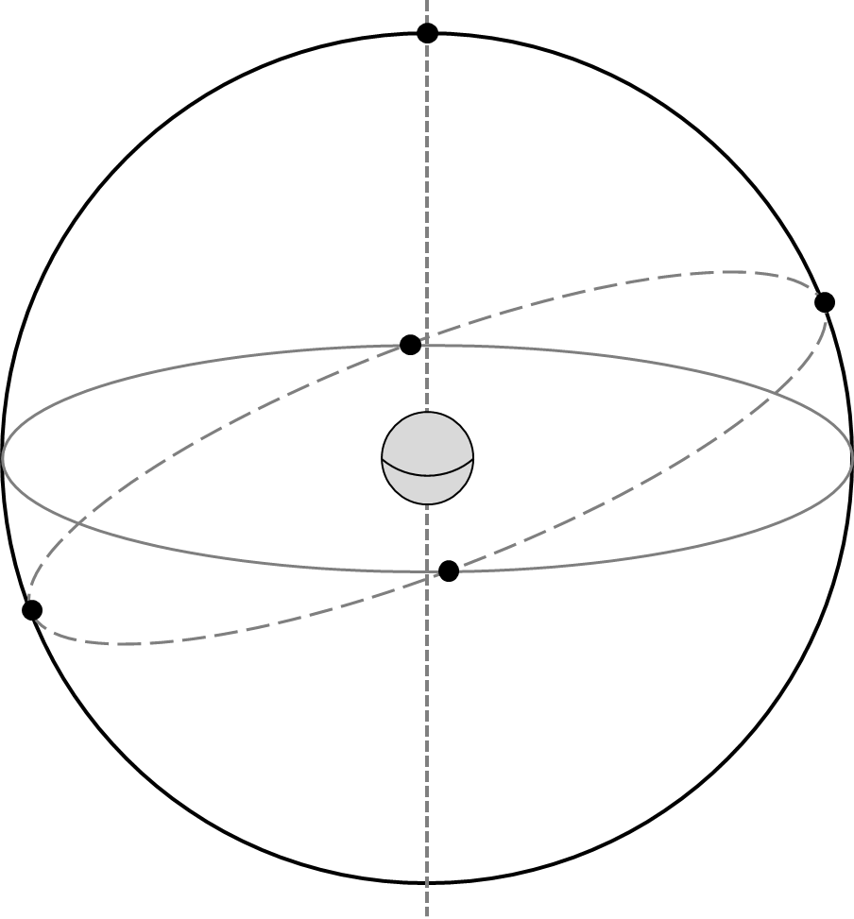

- What angle is the ecliptic inclined with respect to the celestial equator? Include units in your answer.

- What celestial objects lay on or near the ecliptic? Name at least five. Explain more about your answers: What is the significance of the ecliptic? Why do so many noteworthy celestial objects lie in this area of the sky?

- A person stands outside beneath the dome of the night sky. Assume the diagram below is for Iowa City, which is at a latitude of ~42 degrees. Identify and label the following: the Celestial Equator, the North Celestial Pole, Zenith, the Meridian, the Horizon, and the cardinal directions South, East, and West along with their Azimuth Angle. Then draw where Polaris is and draw the path of a star over the course of one night.

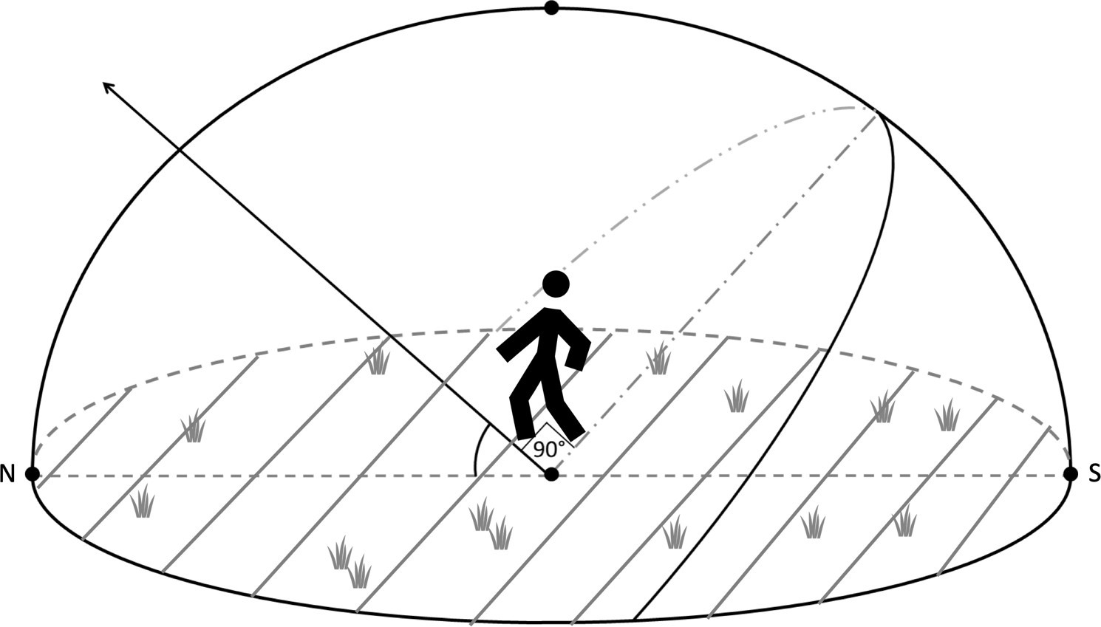

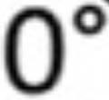

- For Iowa City, what is the Sun’s elevation at noon on the Vernal Equinox? Mark it on the diagram above and include units in your answer.

Hint: Where is the general position of the Sun at noon (on the horizon, below the horizon, high in the sky, etc.)? Next, see the first figure from this lab in Question 1. You labeled the Sun’s exact position when the Vernal Equinox occurs. On that date, where is the Sun is in relation to the Celestial Equator? Remembering the latitude of Iowa City, what is the height of the highest point of the celestial equator in Iowa City?

- For Iowa City, what is the elevation of the Sun at noon on the Summer Solstice? Mark it on the diagram above and include units in your answer.

Part 2: Estimating Angles

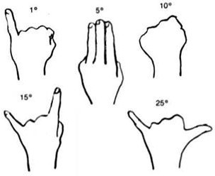
In this part we’ll practice measuring the sky. The main point of this activity will be to estimate the azimuth, altitude, and angular size of a number of objects. The figure below is a handy guide for estimating angles with your hand when held at arm’s length.

- Determine the direction North. Determine the direction of East. On this paper, describe how you would show someone the position of the meridian through the sky, and how it varies from the position of the horizon.

- For each of the following objects, estimate their azimuth angle and their angular size. Your TA will point out any objects that you need help identifying.

Note the following definitions:

Azimuth – angle around the horizon, starting from North and increasing to the East. Ranges from 0° to 360°.
Altitude – angle above the horizon. Ranges from 0° at the horizon to 90° at the zenith.

Object | Azimuth Angle | Angular Size
The Chauncey
Tower Place Parking Ramp Clock Tower
Scout’s Honor Sign
The Vue @ Hilton Garden Inn

