Names:

Grade

Solar Observations

Pre-Lab Quiz:
Record your answers as well as your reasonings and explanations.

1.
2.
3.
4.

Part 1: Features of the Sun

- Several solar features arise from the same magnetic disturbances within the sun and are observed in the different layers of the solar atmosphere as separate phenomenon. Refer to the lab webpage and external sources to label the following solar layers and features as they appear on the diagram below.
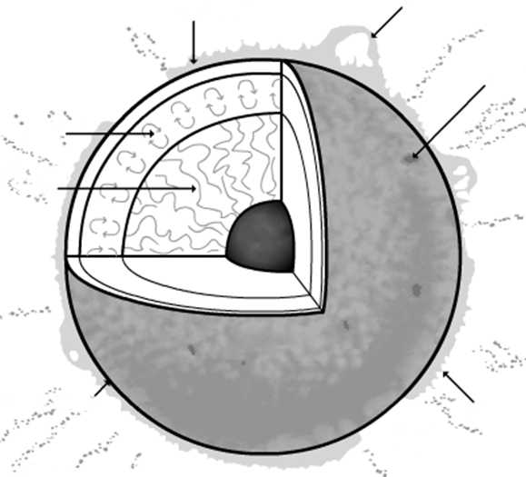
M
L
K
J
E
I
G
F
D
C
B
A
Layer or Feature of the Sun | Corresponding Letter
Core
Photosphere
Convection Zone
Radiation Zone
Photosphere
Chromosphere
Corona
Prominence
Coronal Hole
Sunspot
Filament
Solar Flare
Spicules
Granulation
H

- Pick two types of images of the Sun to study from the following options and record your selection in the chart below:

  - magnetic field pattern images (SDO, sometimes available through BBSO)
  - ultraviolet light images (SoHO, SDO)
  - coronagraph images (SoHO)

Please note: If you chose to study ultraviolet light images, you must select a specific wavelength in Angstroms and write this below (for example, SoHo’s ‘EIT 195’ (A) or SDO’s ‘AIA 211 A’).

Image #1 | Image #2

- Given your filter choices above, which features would you expect to see in your filters of choice and why? Consider which layers of the Sun are being observed.

- Using the paper provided, draw and describe the disk of the Sun as it appears in your first filter. Note any features that are interesting. Call out which features you think you can see and explicitly state which features you cannot see.

- Once again, use the paper provided to repeat this process for your second filter. Draw and describe the disk of the Sun, noting any features that are interesting. Call out which features you think you can see and explicitly state which features you cannot see.

- Compare and contrast what you saw when looking at the two types of images.

(Hint: Are there features that are visible in one filter but not another? In which layer of the Sun might you find these features?)

Part 2: Observing the Sun

- Using the paper provided, draw and describe the disk of the Sun as it appears in Hα light (Coronado solar telescopes) on the diagram below, as viewed through one of the solar telescopes on the roof. Label features and record their locations as accurately as you can, listing notable features below.

- Repeat this process once more, now observing the Sun in white light (Orion Telescopes). Label features and record their locations as accurately as you can, listing notable features below.

- Compare and contrast what you saw when directly observing the Sun in Hα and white light with your images in Questions 3 and 5 of Part 1.

Hint: Were there any features you saw across multiple filters? Similarly, do you notice any connection between the geographic location of one feature and another in different filters? Why do you think this may be?

