Name:

Grade

Lunar Observations

Pre-Lab Quiz:
Record your answers as well as your reasonings and explanations.

1.
2.
3.
4.

Part 1: Lunar Phases
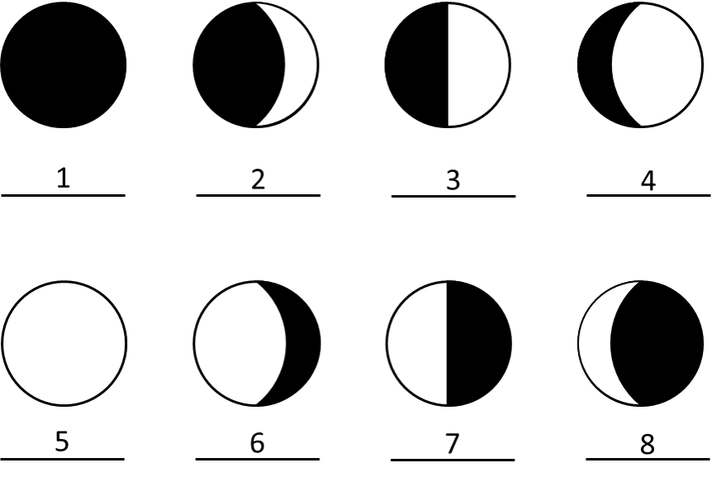
- Identify the phase of the Moon for each case above.

Number | Moon Phase
1
2
3
4
5
6
7
8
- Using Stellarium, which side of the face of the Moon is illuminated today (the left or the right)? By about how much? From that information, what is the current phase of the Moon?

Part 2: Lunar Features

Choosing Your Lunar 100 Card Features
  - Discuss with your group members if you are more interested in observing maria (singular: mare), craters, or both. Spend time looking at the Lunar 100 Card to see the drawn features there and a brief description of these objects. Write the name of the surface feature class you have selected (maria, craters, or both), a brief description of your class choice(s), and why it is/they are of interest to you here.

  - Now you will choose the exact features for observation by your team. Pick two features from the Lunar 100 Card visible on the Moon tonight (use Stellarium to determine what is visible). Choose from the following: 5, 6, 8, 10, 11, 13, 14, 16, 18, 20, 21, 26, 27, 28, 31, 34, 56, 87, 90, 100. Familiarize yourself with where each feature is on the Moon and how big it is, so you can find it easily during our observational activity.
We describe the location of features on the Moon by longitude and latitude, just like here on Earth. The selenographic longitude and latitude can be read from the Lunar 100 map or from the table on the back of the Lunar 100 card. Record information about your features in the table below.

Feature Name | Feature Class | Lunar 100 # | Latitude | Longitude

Studying Information on Your Features
  - This project will be much more interesting and meaningful if you know something about the specific surface features you are observing. Do a bit of internet research on both of your features and note what you learn below. (For example, their formation, age, discovery, notable facts, etc.)
  - Once you are up on the roof, estimate the azimuth, altitude, and angular size of the Moon and record this information below. Reference the diagram and definitions that are also provided.

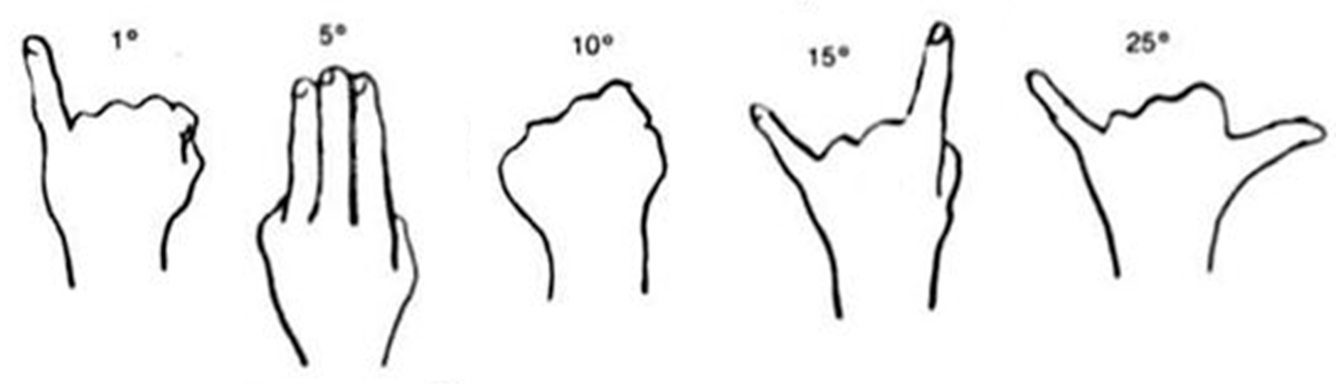
Azimuth – angle around the horizon, starting from the North and increasing to the East. Ranges from 0° to 360°. (Use a resource such as Google Maps to locate North, East where you are.)
Altitude – angle above the horizon. Ranges from 0° at the horizon to 90° at the zenith.

  - Given that the sky rotates 15o per hour towards the west, how many degrees has the Moon traveled since it rose? How many degrees does it need to travel before it sets? Estimate the rise, set, and meridian transit times of the Moon.

For questions 6-9, use the paper provided by your TA and a clipboard to complete your drawings.

Description of Chosen Features
- In the space below, describe your observations of each of your lunar features. Mention how your observations illustrate some aspect of what you learned about your features from reading and researching online for Question 3.

(Backup in Case of Cloudy Skies or for Online Labs:
Lunar Observations with Lunar Reconnaissance Orbiter Spacecraft)
You will find your 2 surface features on the maps of the Lunar Reconnaissance Orbiter (LRO) and use their data to complete questions 8-10 above. The LRO website is linked on the main page of this lab.
The link will automatically open up to a flat view of the near side of the Moon. Before you search for your 2 surface features, it is recommended you open the “Settings” menu on the top left (denoted by the gear icon) and deselect “Show Longitude as 0 to 360”. This will allow you to see the lunar (selenographic) latitude and longitude in the bottom left of the screen as you hover with your cursor.
Once you have changed these settings, you may search for each feature by name or by latitude and longitude. If you use latitude and longitude, note that North and East are represented as positive values, and South and West are represented as negative values, just like geographic coordinates here on Earth. Once you have located a lunar feature you can use the mouse wheel to zoom in and see the feature in greater detail. Now proceed to answer questions 8-10 above, completing your sketches and providing descriptions of what you see.

